

**IVEO TouchPad Installation Instructions**

**Revision: 20100209**

## Table of Contents

### I.   [Installing the IVEO TouchPad](http://manuals.viewplus.com/en/view/print/39/#1_Installing the IVEO TouchPad)

#### A.  [Introduction](http://manuals.viewplus.com/en/view/print/39/#1_A_Introduction)

#### B.  [Insert the TouchPad Installation CD](http://manuals.viewplus.com/en/view/print/39/#1_B_Insert the TouchPad Installation CD)

#### C.  [Plug in the TouchPad](http://manuals.viewplus.com/en/view/print/39/#1_C_Plug in the TouchPad)

#### D.  [Conclusion](http://manuals.viewplus.com/en/view/print/39/#1_D_Conclusion)

### II.   [Installing the IVEO Software](http://manuals.viewplus.com/en/view/print/39/#2_Installing the IVEO Software)

#### A.  [Install the IVEO Software](http://manuals.viewplus.com/en/view/print/39/#2_A_Install the IVEO Software)

### I. [Installing the IVEO TouchPad](http://manuals.viewplus.com/en/view/print/39/#TOC_1_Installing the IVEO TouchPad)

### A.   [Introduction](http://manuals.viewplus.com/en/view/print/39/#TOC_1_A_Introduction)

These instructions apply to IVEO TouchPads with serial numbers 05-000520 and higher. If you have a lower serial number, or if your TouchPad's serial number begins with CIV, you do not need to follow these instructions.

In order for your new IVEO TouchPad to work properly, you must install it using the TouchPad installation CD. Please follow the easy steps below to install your TouchPad.

Note: Do not plug in the TouchPad until instructed to do so by the installation program.

### B.   [Insert the TouchPad Installation CD](http://manuals.viewplus.com/en/view/print/39/#TOC_1_B_Insert the TouchPad Installation CD)

Insert the TouchPad installation CD into your computer’s CD drive. The setup program will start automatically.

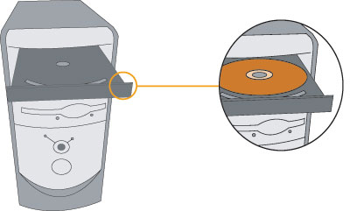

Follow the instructions on the screen to install your TouchPad. Note: Screen Three asks “Do 4 dot calibration”. Please select NONE to ensure the best results.

### C.   [Plug in the TouchPad](http://manuals.viewplus.com/en/view/print/39/#TOC_1_C_Plug in the TouchPad)

When instructed, plug in the TouchPad and close the New Hardware Wizard if it appears.  
  
Place IVEO® TouchPad on a flat surface with the USB port away from you.

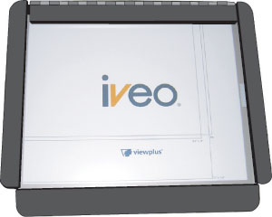

Attach USB cable. Plug the square end of the cable into the TouchPad.

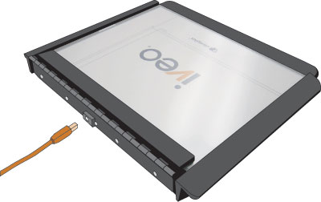

Plug the flat end of the USB cable into the computer.

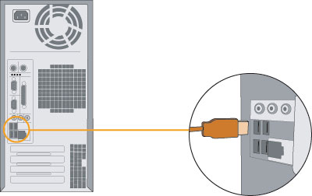

### D.   [Conclusion](http://manuals.viewplus.com/en/view/print/39/#TOC_1_D_Conclusion)

When the setup program is finished, your TouchPad is installed and ready to use.

### II. [Installing the IVEO Software](http://manuals.viewplus.com/en/view/print/39/#TOC_2_Installing the IVEO Software)