ViewPlus Desktop Manual for Models with USB Ports
Revision: 20120419

Table of Contents

I. Introduction

A. Preface

B. FCC Compliance Statement

C. Safety Instructions

D. Specifications

II. Installation

A. Items in the Box

B. Unpacking

C. Software Installation

III. Set Defaults for Printer

A. Windows Printer Defaults

B. Legacy Printer Defaults

C. Service Settings

IV. Operator Panel

A. Functions

B. Display Lights

C. Error Tones

V. Braille, Translation and Printing

A. ViewPlus Tiger Software Suite

B. Fonts

C. Math and Braille

D. Printing

VI. Support, Maintenance and Warranty

A. Training and Support Packages

B. Maintenance

C. Warranty

D. Extended Warranty and Maintenance Plan

I. Introduction

A. Preface
ViewPlusTiger Desktop Series
ViewPlus Max/Cub/Cub Jr.
Tactile Graphics and Braille Embossers, powered by Tiger
Owner's Manual

Congratulations on owning one of the ViewPlus Desktop Series braille and graphics embossers! This manual will introduce you to basic information regarding your new printer. The ViewPlus Technologies web site is another resource for information on your ViewPlus embosser including examples, tutorials and other useful downloads.

Visit the web site at: http://www.viewplus.com

Your embosser is Powered by Tiger. This means:

Braille production made flexible and easy
- Braille is translated and embossed from MS Word in one touch
- Graphics are produced from any PC software including Illustrator & CorelDraw
Tactile graphics embossed in fine detail – better than any braille printer
- Tiger tactile graphics are the highest-resolution of any embosser
- Dot-height adjusts higher or lower for dark or light areas in images – 8 levels
Braille & graphics software included - Tiger Software Suite (TSS)
- TSS incorporates braille software, tactile graphic studio, and more
- Tigers are also compatible with Duxbury and other braille software
ViewPlus Tiger-brand embossers all include Powered by Tiger technology – models differ in size and price depending mostly on printing speed and paper/media width. Ink and braille models are available as well as cut-sheet paper feeders for certain units.

For more information on ViewPlus Powered by Tiger functionality, visit http://www.viewplus.com/products/powered-by-tiger/

Model Numbers for the Desktop Series:
ViewPlus Max: 081402
ViewPlus Cub: 080804
ViewPlus Cub Jr. 040802

USER'S Manual

B. FCC Compliance Statement

FCC Compliance Statement (USA)
This equipment has been tested and found to comply with the limits for a Class A digital device, pursuant to Part 15 of the FCC Rules. Operation is subject to the following two conditions: (1) this device may not cause harmful interference, and (2) this device must accept any interference received, including interference that may cause undesired operation. If this equipment does cause harmful interference to radio or television reception, which can be determined by turning the equipment off and on, the user is encouraged to try to correct the interference by one or more of the following measures:
- Reorient or relocate the receiving antenna.
- Increase the separation between the equipment and receiver.
- Connect the equipment to an outlet on a circuit different from that to which the receiver is connected.
- Consult the dealer or an experienced radio/TV technician for help.

FCC Warning: Changes or modifications not expressly approved by the party responsible for compliance could void the user's authority to operate the equipment.
Note the following:
- The use of a non-shielded interface cable with the referenced device is prohibited.
- The length of the parallel interface cable must be 3 meters (10 feet) or less.
- The length of the serial interface cable must be 15 meters (50 feet) or less.
- The length of the power cord must be 3 meters (10 feet) or less.
Compliance Statement (Canada)
This digital apparatus is in conformity with standard NMB-003 of Canada.
Cet appareil numérique est conforme à la norme NMB-003 du Canada.

Compliance Statement (Germany)
Bescheinigung des Herstellers/Importeurs:
Hiermit wird bescheinigt, dass der Drucker der Maschinenlärminformationsverordnung 3. GSGV, 18.01.1991 entspricht: Der höchste Schalldruckpegel beträgt 70 dB(A) oder weniger gemäß EN27779-1991.

Compliance Statement (Europe)
Warning: This product meets the interference requirements of EN55022. In a domestic environment, this product may cause radio interference in which case, the user may be required to take adequate measures.

Compliance Statement (Korea)
This apparatus complies with CISPR22 requirements.

International Compliance

EN55022:1994 Emissions series
EN55024:1998 Immunity characteristics
EN61000-3-2:1995 Power line harmonics
EN61000-3-3:1995 Power line flicker
EN61000-4-2:1995 Electrostatic discharge
EN61000-4-3:1995 Radiated susceptibility
EN61000-4-4:1995 Electrical fast transient/burst
EN61000-4-5:1995 Surge
EN61000-4-6:1996 Conducted immunity
EN61000-4-11:1994 Input voltage interruptions/DIPS

CE MDD
Authorized European Representative
ViewPlus BV - Europe
Rudolf Dieselweg 36D
5928 RA Venlo
The Netherlands
+31 (0)77-7676001
e-mail: viewplus_europe@viewplus.com
Waste Electrical and Electronic Equipment (WEEE) Compliance
ViewPlus BV complies with EU Directive 2002/96 regarding WEEE recycling; upon the conclusion of the product lifecycle, please contact ViewPlus BV concerning proper disposal.

C. Safety Instructions
Read all of these safety instructions before using the printer. In addition, follow all warnings and instructions marked on the printer itself.
- Do not place printer on an unstable surface.
- Do not place printer near a radiator or heat source.
- Do not block or cover slots and openings in the printer's cabinet; do not inset objects through slots.
- Use only the type of power source indicated on printer's label.
- Connect all equipment to properly grounded electrical outlets.
- Do not use frayed or damaged power cord.
- The use of an extension cord with the printer is not recommended.
- Unplug printer before cleaning it; always clean it with a piece of damp cloth only.
- Do not spill liquid into printer.
- Except as specifically explained in the user's manual, do not attempt to service the printer by yourself.
- Detach the printer from power source and refer to qualified service personnel under the following conditions:
  - If the power cord or plug is damaged
  - If liquid has entered the printer.
  - If printer has been dropped or the cabinet is damaged.
  - If the printer does not operate properly or exhibits a distinct change in performance.
- Only adjust those controls that are covered by the operating instructions.

D. Specifications
 | ViewPlus Max | ViewPlus Cub & ViewPlus Cub Jr.
Character Sets | DotsPlus & Braille Screen fonts | DotsPlus & Braille screen fonts
Paper Feed Method | tractor paper feed  single sheet | tractor paper feed  single sheet
Paper Maximum Thickness | Maximum 0.35mm (0.014 inches) | Maximum 0.35mm (0.014 inches)
Paper Width | up to 355 mm (14 inches) | up to 216 mm (8.5 inches)
Power Supply | From 100 - 120 V  (or 220 - 240 V)  Current rating: 1.2 A  (or 0.65 A)  Frequency: 50 - 60 Hz | From 100 - 120 V  (or 220 - 240 V)  Current rating: 1.2 A  (or 0.65 A)  Frequency: 50 - 60 Hz
Power Consumption | Standby 10 W  Average Print 85 W | Standby 10 W  Average Print 85 W
Embosser Dimensions  Width  Depth  Height  Weight | 22.5 in. (572 mm)  13.2 in. (335 mm)  6 in. (152 mm)  22 lbs. (9.98 kg) | 16.8 in. (427 mm)  13.2 in. (335 mm)  6 in. (152 mm)  17.5 lbs. (7.95 kg)
Interface | USB | USB
Operating Conditions
Temperature | 41° to 100° F (5° to 38° C) | 41° to 100° F (5° to 38° C)
Relative Humidity | 30% to 80% RH (non condensing) | 30% to 80% RH (non condensing)
Reliability | 15,000 hours @ 5% duty cycle | 15,000 hours @ 5% duty cycle
Computer Requirements
Operating System | Windows XP or later | Windows XP or later

II. Installation

A. Items in the Box
- ViewPlus Desktop Series Embosser
- Power cord
- Paper knob
- USB cable
- CD with software, manual and copies of documentation
- Tactile print out
- Tiger Software Suite

B. Unpacking
- Remove the printer and all its accessories from its packaging.
- Inspect the ViewPlus embosser and its packaging for any damage.
- Open lid and remove the shipment locks surrounding the print head.
- Save the packing material and box. If any damage occurred during shipping, most shipping companies require the box and the packing material in order to settle the insurance claim. The packing material must also be used to ship the ViewPlus embosser for warranty maintenance service.

C. Software Installation
Please follow the easy steps that are part of your Setup Instructions to install your Tiger driver. They can also be found on your installation CD.

III. Set Defaults for Printer

A. Windows Printer Defaults
The Windows printer settings for your ViewPlus Desktop embosser are accessible from its printing preferences dialog. To open the printing preferences dialog, choose Start>Printers and Faxes on Windows XP or Start>Devices and Printers on Windows 7 or Vista. In the printer list, right-click on the ViewPlus Max, Cub or Cub Jr. and choose the 'Printing Preferences...' option. In addition, the printing preferences dialog is accessible using the 'Properties' button next to the printer selection box on the standard Windows print dialog used to print from most programs.

The printing preferences options are organized onto three tabs. The Layout tab contains options pertaining to the page layout of the document to be printed. Use the descriptions of the options on the Layout tab to help make the appropriate selections for the document.

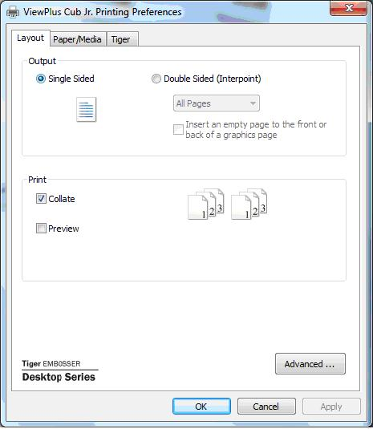
Shows Layout Tab

- Output - Select the desired duplexing option.
  - Single Sided - Select this option if you do not want the back sides of the pages printed.
  - Double Sided (Interpoint) - Select this option if you want the back sides of the pages printed. If Double Sided (Interpoint) is selected, make selections for the following options:
    - Pages - Select whether to print All Pages, Odd Pages or Even Pages. The default is All Pages. The Odd Pages and Even Pages options can be useful to complete a print job if you have printed part of a manual interpoint document and did not turn the pages over before clicking OK on the print dialog to print the second side.
    - Insert an empty page to the front or back of a graphics page - Select whether to insert a blank page on the back side of pages that contain graphics. Do not select this option if you have already inserted blank pages after graphics pages in your document.
- Print - Select the desired printing options:
  - Collate - When the collate box is checked and multiple copies of a document are printed, one complete document will be embossed at a time. If the collate box is left unchecked all copies of each page will be embossed before embossing of the next page in the document begins.
  - Preview - If this option is checked, a preview of how the document will print and emboss will be shown in Tiger Viewer instead of printing.
- Advanced - This button brings up a dialog containing additional options only needed by advanced users. These options are:
  - Rotated Landscape - When checked, this option rotates landscape pages 180 degrees. This option is generally only used for spreadsheets, where it is helpful for the information to appear as it does on screen when printed on continuous (tractor fed) paper.
  - Horizontal Shift - This option is usually used when printing manual interpoint. When printing interpoint with All Pages selected, this option should not be needed. However, it is often useful when printing Even Pages and Odd Pages as separate print jobs.
The Paper/Media tab contains options related to the type of paper or media being used for printing. Select the desired options for your media.

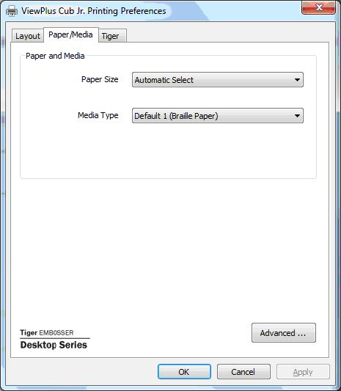
Shows Paper/Media Tab
- Paper and Media - Select the options that apply to your media.
  - Paper Size - Select the paper size you are using from the list, or leave the setting at Automatic Select to allow the application you are printing from to choose the correct paper size for you.
  - Media Type - Select the type of media you are using.
- Advanced - Selecting the 'Advanced...' button brings up the Advanced dialog, which allows you to create and manage custom media types and paper sizes.
  - Media Types
    - Choosing the 'Add...' button will allow you to define a new custom media type. The 'Print Media Type Test Pattern' button will print a selection of punch forces from which you can choose to set the highest and lowest punch force values that work for your media.
    - Selecting a media type from the drop-down list and choosing 'Edit...' will allow you to edit that media type. Note: Default media types can not be edited.
    - Selecting a media type from the drop-down list and choosing 'Remove' will delete that media type from the list. Note: Default media types can not be removed.
  - Available Forms
    - Choosing the 'Add Custom Form...' button will allow you to define a new paper size. Note: Paper sizes wider than 14 inches may not be added to the ViewPlus Max, and paper sizes wider than 9 inches may not be added to the ViewPlus Cub or Cub Jr.
    - Selecting a paper size in the list will show the paper dimensions in the selected units of measure. If the selected size is a custom size, the 'Delete Form' button will be available.
    - Choosing the 'Delete Form' button will remove the selected form.
The Tiger tab allows you to control braille and print options for printing. Use the descriptions below to help you make your selections.
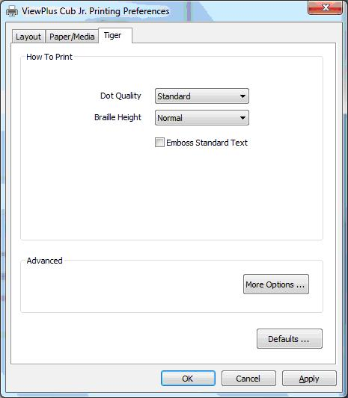
Shows Tiger Tab
- How to Print - Select the print and braille options appropriate for your document.
  - Emboss - When this option is checked, the embosser will create embossed output.
    - Dot Quality - Select Standard or Best dots. Printing with standard dot quality is the faster option. Selecting best dot quality causes the printer to punch each dot twice, leading to rounder, smoother dots.
    - Braille Height - Select Low, Normal or High braille dot height. Normal dot height sets the braille dots to the same height as the highest graphics dots. Adjust the braille dot height higher or lower to suit the reader.
    - Emboss Standard Text - When checked, all text except interline will be embossed. This is helpful when used with a large font to print raised letters.
- Advanced - Select the advanced printing options appropriate for your document.
  - More Options - Selecting the 'More Options...' button brings up an Advanced dialog, which from this tab allows you to set advanced options.
    - Images - Select the desired image options. These settings apply only to the embossed output.
      - Invert Colors - When checked, this option embosses light colors as high dots and dark colors as low dots.
      - Contrast - The default setting is 0. The range is from -100 to 100. Increasing the contrast increases the dot height difference of two colors that have intensities that are nearly the same. By increasing the contrast, light colors get lighter and dark colors get darker.
      - Brightness - The default setting is 0. The range is from -100 to 100. Increasing the brightness can be useful to increase the intensity of all the colors. This option is most often used with images in which lines are thin and light.
      - Thin Line Intensity - If lines in graphics are too thin to emboss correctly, slide the indicator to the right.
    - Defaults - The 'Defaults...' button will restore all settings on the Advanced dialog to their default values.
- Defaults - The 'Defaults...' button will restore all settings on the Tiger tab to their default values.

B. Legacy Printer Defaults
The Device Settings options allow you to control settings in the embosser. You can access the Device Settings page through Start>Printers and Faxes on Windows XP or Start>Devices and Printers on Windows 7 or Vista. In the printer list, right-click on the ViewPlus Max, Cub or Cub Jr. and choose the 'Properties' option. On the dialog that comes up, select the Device Settings tab.

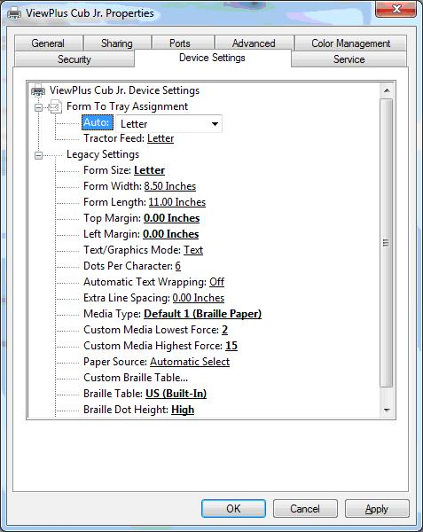
Shows Device Settings Tab

The first section of the Device Settings tab controls the embosser's "tray assignment", allowing you to set what paper size is loaded into the embosser.

The second section of the Device Settings controls the embosser's legacy settings. These settings are used when you print to the Max, Cub or Cub Jr. from programs that do not use the Windows printer driver, including some braille programs. Use the descriptions below to make your selections.
- Form Size - Select a standard page size, or select Custom to set the page size manually.
- Form Width - This field shows the page width. For standard page sizes, this field is informational only. If the Form Size is set to Custom, this field is editable.
- Form Length - This field shows the page length. For standard page sizes, this field is informational only. If the Form Size is set to Custom, this field is editable.
- Top Margin - Set the top margin to be used when printing in legacy mode. Note: If you are printing from an application that sends margin information with the print job, set the top margin to 0.
- Left Margin - Set the left margin to be used when printing in legacy mode. Note: If you are printing from an application that sends margin information with the print job, set the left margin to 0.
- Text/Graphics Mode - Select Text mode if your legacy document contains text. If the document is a graphic, select Graphics mode to remove the space between braille lines so that dots may be printed in an even grid.
- Dots Per Character - Select 6 or 8 dots.
- Automatic Text Wrapping - Select 'On' if lines in the document are longer than will fit on one printed line and you do not wish the lines to be truncated. If the document is formatted correctly for the page size and margins you are using, or if you do not wish to have long lines wrapped to the next line, select 'Off'.
- Extra Line Spacing - Set the amount of extra space desired between braille lines. This setting can only be set in multiples of 0.05 inches.
- Media Type - Select a default media type from the list, or choose Custom to set the punch forces manually for non-standard media.
- Custom Media Lowest Force - Enter the punch force value to be used for the lowest dots on a custom media type.
- Custom Media Highest Force - Enter the punch force value to be used for the highest dots on a custom media type.
- Paper Source - Select the source for the paper.
- Custom Braille Table... - This option allows you to load a braille table. The embosser can store up to six braille tables.
- Braille Table - Select which braille table to use when printing.
- Braille Dot Height - Select Low, Normal or High to control how tall the braille dots print.
- Auto Load Paper - Select whether to load paper automatically to top of form.

C. Service Settings
The Service tab provides information about and servicing functions for your ViewPlus Desktop embosser. When contacting ViewPlus Support, please have the driver and firmware versions and the serial and model numbers of your ViewPlus Max, Cub or Cub Jr., shown on this tab, available. Please do not adjust any settings on this page unless directed to do so by ViewPlus Support.
- Open Tiger Toolbox... - This button launches the Tiger Toolbox application. Please do not adjust any settings in the Tiger Toolbox unless directed to do so by ViewPlus Support.
- Embosser Information - At the bottom of the Service tab, information about your Max, Cub or Cub Jr. is displayed, including the printer driver and firmware version numbers, the embosser serial number and the model number.

IV. Operator Panel

A. Functions
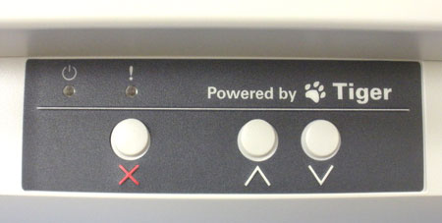
(The buttons are described from left to right order.)
- Cancel - This button is used to cancel a print job or clear a warning message indicated by an LED and error tone.
- Up Arrow - This button is used to load paper, or move the paper forward to tear. Pressing and holding this button will move the paper continuously forward.
- Down Arrow - This button is used to move the paper back to the ready position after the embossed sheet is torn off. Pressing and holding this button will move the paper continuously backward.

B. Display Lights
- Power - This green light is on when the ViewPlus embosser is ready to receive data. It blinks when printing.
- Warning - This orange light is blinking if the ViewPlus embosser is unable to print. All warnings are accompanied by an error tome. Most often, this light indicates that there is no paper present.

C. Error Tones
- Paper Out - Beep sequence (high, low) repeats every 10 seconds until user presses Cancel.
- Paper Jam - Beep sequence (high, low, high) repeats every 10 seconds until user removes the jammed paper and presses Cancel.
- Alignment error - Beep sequence (high, high, low) repeats every 10 seconds until user fixes problem and presses Cancel. Make sure nothing such as paper covers the shiny area of the platen. It may be necessary to brush off paper dust off of this area.
Other Beep Signals - If you hear any other series of beeps, you may have a serious problem. Please listen carefully so that you can describe the tone to technical support.

V. Braille, Translation and Printing

A. ViewPlus Tiger Software Suite
Most braille should be produced using the Tiger Software Suite. The Tiger Software Suite is part of your embosser package. Instructions for installation and use come with the software package.

B. Fonts
Tiger screen fonts are alternative braille fonts installed during the installation of the ViewPlus embosser driver. They can be chosen as output options in Tiger Software Suite (TSS) and other software programs, like MathType. Tiger screen fonts appear as standard text characters on the screen and print as braille dot patterns.

It is very important to use the default font size and spacing for braille fonts. If the font size or spacing is changed, the braille will not be printed with the correct standards. For Tiger fonts, a point size of 36 is suggested. Most other braille fonts will use a point size of 29.

Characters or text not translated to braille will print as graphic images of the visual character.This enables embossing of visual print characters. More information about the fonts included can be found on your installation CD in the Tiger/Docs folder.

C. Math and Braille
Create braille math documents using the Tiger Software Suite 4.0 and MathType 5.0 or higher from Design Science. Insert text, graphics and math equations directly into a Microsoft Word document and translate to braille in one easy step. Equations will appear in both braille and ink allowing sighted readers to follow along. More information about braille math can be found on the ViewPlus website.

D. Printing
Now the installation is complete, you should be set to print a document. These are the steps that you should follow to print:
- Open the document to be printed.
- Open the program's File menu and choose Print.
- On the Print dialog, make sure a ViewPlus embosser is selected. Click on the printer properties button and ensure that the correct paper size and Tiger printing options are selected. Click OK on the printer properties dialog when you are finished. Then click OK on the Print dialog to start the print job.
- If you are using form feed paper when the printer is finished, press the up arrow button to advance the paper enough so you can detach it. Press the down arrow button after you have detached the paper to move the paper to the ready position.
- There are example documents and tips for using various Windows applications at: http://www.viewplus.com/support/examples/

VI. Support, Maintenance and Warranty

A. Training and Support Packages
Tutorials and other support materials are available on the ViewPlus website. For these resources and other support inquiries, please visit http://www.viewplus.com/support/.

Additional training and support is available for purchase through your authorized ViewPlus distributor or from ViewPlus Technologies.

B. Maintenance
It is important to choose a suitable location for the ViewPlus embosser. The cable length between the printer and the host computer should not exceed ten feet (three meters). The location should be sturdy and flat. The printer should not be exposed to direct sunlight, extreme heat, cold, dust or humidity. The AC power outlet must be compatible with the plug of the printer's power cord. Dot quality should be monitored; poor alignment can cause permanent damage to the platen of the ViewPlus embosser.

Software updates can be downloaded from the ViewPlus Technologies web site. You should occasionally check the web site for the latest developments.

C. Warranty
For information on your product warranty, please visit our web site. Select the appropriate link to your warranty information based on your region from the choices below.
- For the US/Canada, please see your manufacturer's warranty information at http://www.viewplus.com/support/warranty
- For Europe, please see your manufacturer's warranty information at http://www.viewplus.eu/support/warranty
- For Asia, please see your manufacturer's warranty information at http://www.viewplus.com/support/warranty
- For South America, please see your manufacturer's warranty information at http://www.viewplus.com/support/warranty
- For Australia, please see your manufacturer's warranty information at http://www.viewplus.com/support/warranty
- For Africa, please see your manufacturer's warranty information at http://www.viewplus.com/support/warranty

D. Extended Warranty and Maintenance Plan
An extended warranty and maintenance plan is available through ViewPlus Technologies or your ViewPlus representative. A copy of this plan was shipped with your ViewPlus embosser. It can also be found on our web site: http://www.viewplus.com/products/braille-embossers/warranty/

Availability is limited to customers with valid existing warranty.

