
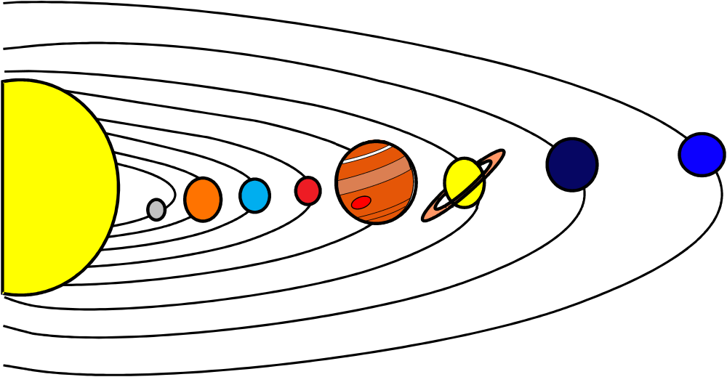
PRIVATE VPTrans skip story \* MERGEFORMAT ,solar ,system

PRIVATE VPTrans skip story \* MERGEFORMAT Solar System

,neptune

,uranus

,saturn

,jupiter

,mars

,earth

,venus

,mercury

,sun

_+www.viewplus.com_:

Neptune

Uranus

Saturn

Jupiter

Mars

Earth

Venus

Mercury

Sun

www.viewplus.com

