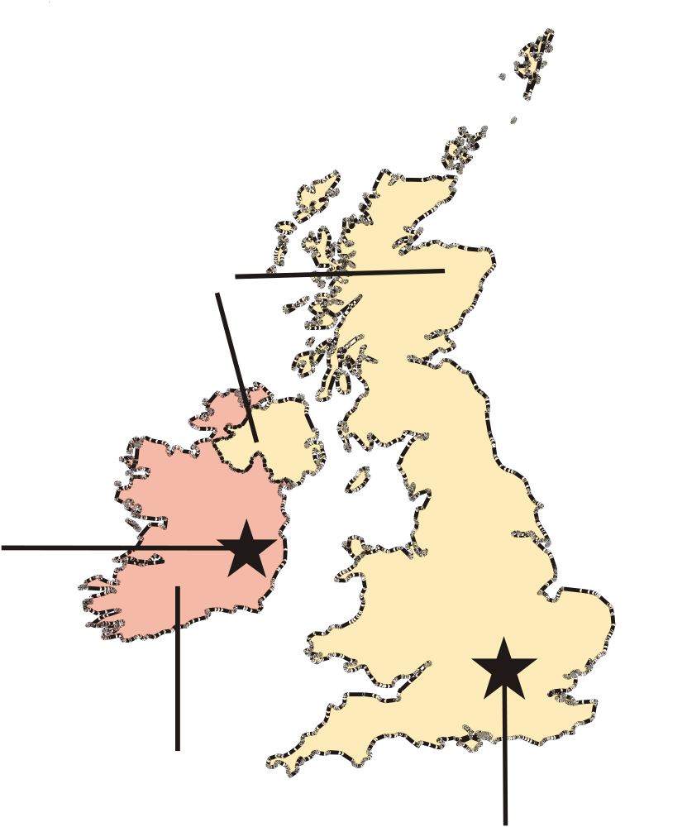

PRIVATE VPTrans skip story \* MERGEFORMAT ,united ,kingdom

PRIVATE VPTrans skip story \* MERGEFORMAT ,dublin

PRIVATE VPTrans skip story \* MERGEFORMAT Dublin

PRIVATE VPTrans skip story \* MERGEFORMAT ,london

PRIVATE VPTrans skip story \* MERGEFORMAT London

PRIVATE VPTrans skip story \* MERGEFORMAT ,ireland

PRIVATE VPTrans skip story \* MERGEFORMAT Ireland

PRIVATE VPTrans skip story \* MERGEFORMAT United Kingdom

PRIVATE VPTrans skip story \* MERGEFORMAT _+www.viewplus.com_:

PRIVATE VPTrans skip story \* MERGEFORMAT www.viewplus.com

,map of ,united ,kingdom and ,ireland

Map of United Kingdom and Ireland

Map of United Kingdom and Ireland

