The VP Cub: High resolution embossing at the lowest price
- The ViewPlus Cub utilizes proven ViewPlus technology to emboss Braille and High Resolution Tactile Graphics with variable dot heights
- Provides input for both endless tractor fed and single cut sheet paper up to A4 or letter size
- Is lightweight and compact
- Provides easy connectivity and setup

The Braille dot produced by ViewPlus embossers can be adjusted in height, allowing to adjust to the individual sensibility of the reader's finger tip. This makes extended Braille reading more enjoyable while maintaining unsurpassed detail in producing tactile graphics. The unique shape of the ViewPlus dot is proven to make Braille more durable, thus allowing documents to last longer over time.

ViewPlus solutions include Windows printer drivers that will allow embossing directly from Windows programs, utilizing the same process as printing to main stream color printers.
What you see on the screen is what the VP Cub will print, representing the color spectrum from white to black in 7 different heights of the embossed dots.

The ViewPlus Cub is the lowest priced solution to combine Braille with high quality tactile graphics. Its ease of use, light weight and compact desktop size makes it the ideal companion for teachers or students who emphasize on learning through tactile graphics, but don't need color overprints.

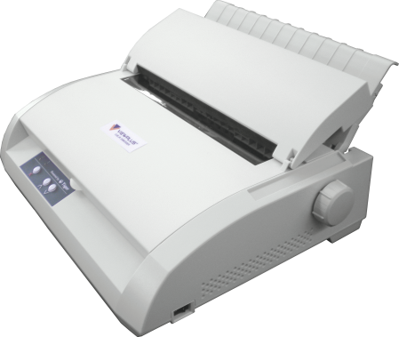
A free license of the VP Tiger Software Suite (VP TSS) for Braille translation, tactile graphics design and more is included when purchasing a ViewPlus embosser. TSS allows the user to create Braille documents in standard Windows programs such as MS Word and Excel without needing to know Braille.

For more information please contact sales@viewplus.com or call 866-836-2184
www.viewplus.com
Specifications:

Print Speed: Up to 50 CPS
Printing Mode: Single sided
Tactile Resolution: 20 DPI
Tactile Graphic Dot Heights:
7 steps for color representation
Braille Dot Heights:
Adjustable in 3 heights
Paper Width: 4 - 8.5 in
(101 - 216 mm)
Paper: Continuous,
Single Sheet Feeder
Paper Weight: 30 - 140 lb
(50 - 230 gsm)
Connection: USB (1.1, 2.0)
Compatibility: Windows XP, 7, 8
Height: 5.75 in (146 mm)
Width: 17 in (432 mm)
Depth: 13.5 in (343 mm)
Weight: 17.5 lbs (7,95 kg)
Recommended Temperature:
41 - 95 °F (5 - 35 °C)
Storage Temperature:
-4 - 158 °F (-20 - 70 °C)
Humidity: 20 - 80% RH
(non-condensing)
Energy Supply:
100 - 120 V, 220 – 240 V
50/60 Hz (+/- 3%)
Standby: 10 W
Heavy Embossing: 85 W

