InkConnect
Service Manual
6/1/2010
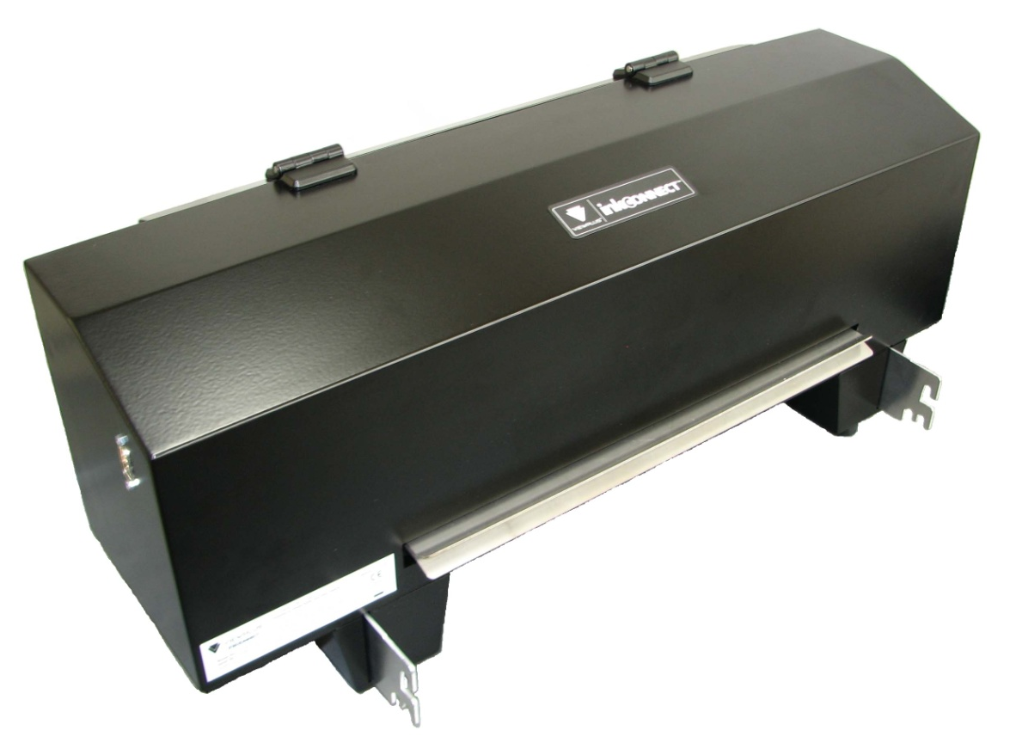

Table of Contents
I Safe installation/removal of InkConnect 4-5
1. Installation of InkConnect to Elite/Premier embosser 4-5
o Identifying power switch 4
o Identifying serial cable 4
o Attaching InkConnect 5
2. InkConnect removal from Elite/Premier embosser 5
o Turning off power 5
o Detaching the serial cable 5
o Removing InkConnect 5
II Common problems 6-11
1. Ink and embossing not aligned 6-7
o Alignment procedure 6
o One and two pass printing 6-7
2. Ink cartridge troubleshooting 7-8
o Installing ink cartridge 7
o Checking ink cartridge fill 7
o Priming ink cartridge 8
o General considerations 8
3. Problems with ink output 8-10
o Ink skew calibration 8-9
o Cartridge spacing 9
o Checking cartridge wipers 10
4. Paper jamming 10-11
o Diagnosing paper jam 10-11
o Plastic deflector replacement/adjustment 11
III Hardware disassembly/replacement 12-26
1. Case 12-13
o Identifying Case components 12
o Removing case for service 12-13
2. Carriage assembly 14-16
o Identifying carriage components 14
o Removing the carriage assembly 14-16
3. Drive motor, belt and tensioning assembly 17-19
o Identifying belt drive and tensioning components 17
o Tensioning the belt properly 17
o Removing the belt tensioning assembly 18
o Motor replacement 18-19
4. Electronics 20-26
o Electronic component identification 20
o Replacing the main board 20-21
o Replacing the case sensor 22
o Replacing the home flag sensor 23
o Replacing the flat flex ribbon cables 24-25
o Replacing interconnect cable 25-26

I Safe removal/installation of InkConnect
This section is designed to outline the basic procedures of attaching and removing the InkConnect from either the Elite or Premier embosser. It is most important to note that during either of these actions, it is essential for the power source to be disconnected from the embosser.
1. Installation of the InkConnect to Elite/Premier embosser
Identifying power switch
Below is a picture of the power switch on the back of the Elite/Premier embossing line of printers. This is the same switch that turns on the InkConnect when it is connected to the embosser via the serial cable. Make sure that the switch is turned off “o” when either connecting or disconnecting the InkConnect.
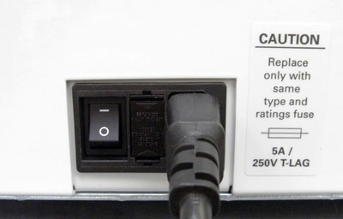
Identifying serial cable
Below is a picture of the serial cable between the Elite/Premier embosser and the InkConnect. The cable is included in the box with each InkConnect. To install the cable, screw the male end into the back of the embosser, and the female end into the InkConnect, using the screws embedded into the cable connectors. Ensure that the embosser power is disconnected before installing the serial cable. When installed properly, the cable will stay plugged in even when pulled.
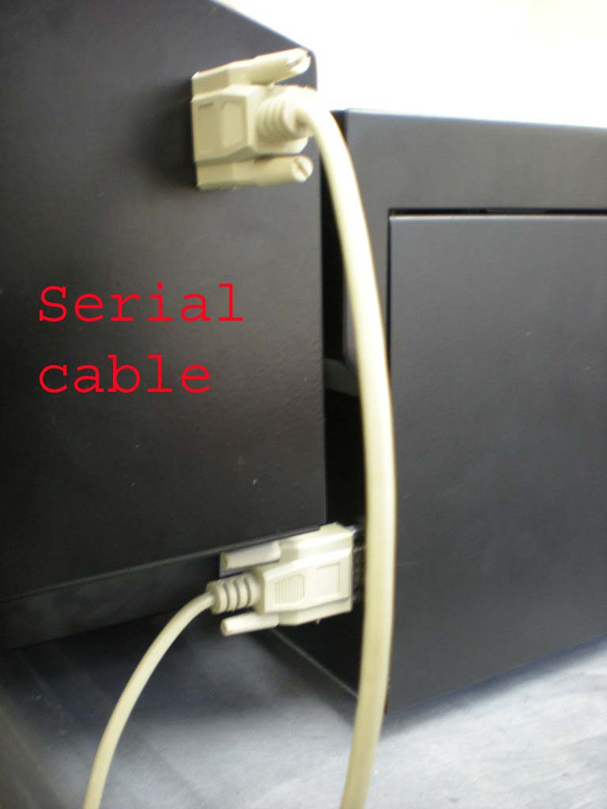
Attaching InkConnect
To install the InkConnect onto the back of either the Elite or Premier, lift the InkConnect and attach the mounting hooks to the mounting posts inside the back of the Elite or Premier. The mounting hooks are shown in the picture below. The mounting posts are inside the 2 long slots pictured in the back of the Elite. For best success, lift the top of the mounting hooks to the top of the long slots before sliding the hooks into the back of the Elite. Slide the mounting hooks straight in, and then drop them down onto the mounting posts. Once the hooks engage the posts, push down slightly on the InkConnect to ensure that it has settled fully onto the mounting posts.
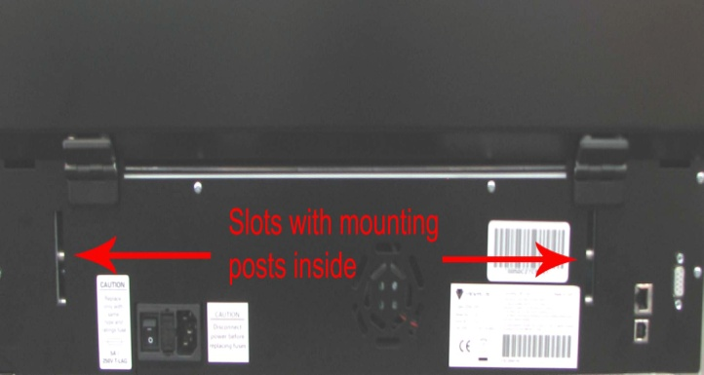
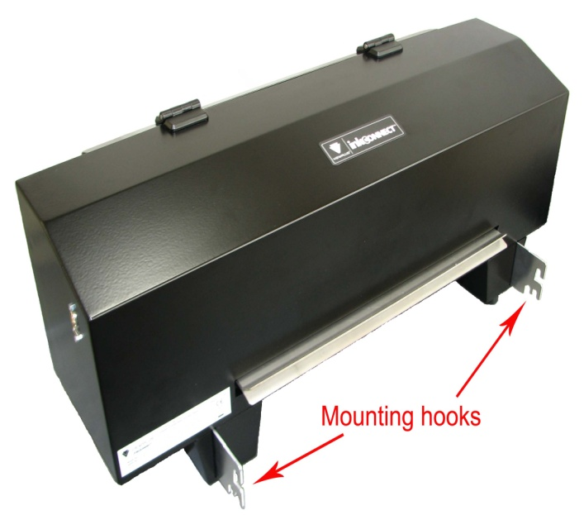
2. InkConnect removal from Elite/Premier embosser
Turning off power
Before removing the InkConnect it is crucial that the power source be disconnected from the embosser. Make sure the power switch is set to the off “o” position, and then disconnect the power cable from the embosser.
Detaching the serial cable
Besides power considerations it is safer to remove the serial cable from the InkConnect before detaching it from the embosser. If the cord is left attached it could get caught up and cause the InkConnect to be dropped or bang against the embosser. Ensure that there is a solid flat surface available before detaching the InkConnect. To detach the cable unscrew the embedded screws from the InkConnect.
Removing InkConnect
Before removing the InkConnect make sure the embosser power source is turned off and the serial cable is disconnected from the InkConnect. To remove the InkConnect grab both sides of the case and lift up. This will lift the mounting hooks off the mounting posts inside the embosser. When the hooks are disengaged, pull the InkConnect straight back, away from the embosser.

II Common problems
This section is designed to diagnose and give suggestions about common problems that could occur with the InkConnect.
1. Ink and embossing not aligned
Alignment procedure
If the ink and embossing are not aligned in a printout the first step to try and correct the problem is to readjust the ink alignment. To adjust the alignment, first go to the service tab for the ViewPlus Tiger Elite or Premier embosser with InkConnect. In the service tab click the “Ink-Emboss Alignment” button shown in the picture below. This prints the ink/emboss alignment page, which allows you to change the horizontal and vertical placement of the ink with respect to the embossing. The pattern is two numbered sets of 11 embossed rectangles with 11 ink rectangles overlapping them; one set of rectangles is for the horizontal placement and the other is for vertical placement. To set the horizontal placement, locate the embossed rectangle in the "Horizontal" set that is perfectly horizontally aligned with the corresponding ink rectangle and enter its number into the Horizontal field. To set the vertical placement, locate the embossed rectangle in the "Vertical" set that is perfectly vertically aligned with the corresponding ink rectangle and enter its number into the Vertical field.
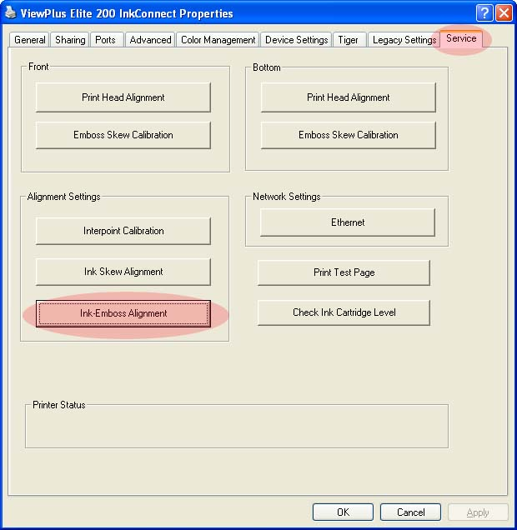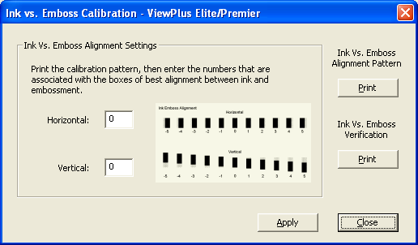
One and two pass printing
When the duplex option is set to double-sided (interpoint) and the ink option is checked, the one pass print ink and two pass print ink options become available. Selecting one pass print ink will print the ink corresponding to both the front and back sides of each page on the front of the page, and the Braille and all the ink will be printed in one pass of the paper through the printer. Selecting two pass print ink will print the braille for both sides and the ink for the front sides of the pages in one pass, then require the paper to be flipped over and reinserted into the printer to print the ink on the back sides of the pages. An extra sheet of blank paper at the end of the embossed pages is required when using the two pass print ink option. If the one pass printing option is selected, the ink and Braille will not match up perfectly, due to the formatting necessary to fit two pages of ink data onto a single Braille page.
2. Ink cartridge troubleshooting
Installing ink cartridge
To install a new ink cartridge first remove it from the foil wrapper, then peel off the piece of tape that covers the ink cartridge nozzles. Open the back lid of the InkConnect to gain access to the printer carriage. Insert the bottom side of the ink cartridge into the bottom of the TIJ 1 carriage, and then rotate the top of the ink cartridge back into place. There should be a snapping sound when the cartridge is installed correctly. To verify correct cartridge installation and placement pull gently straight outward on the middle portion of the cartridge, if the cartridge remains seated in the carriage, it has been installed correctly.
Checking ink cartridge fill
If no ink output is coming from the InkConnect during print jobs it may be due to empty cartridges. To determine if the ink cartridges may be empty, check the fill status by accessing the service tab then clicking the “Check Ink Cartridge Level” button.
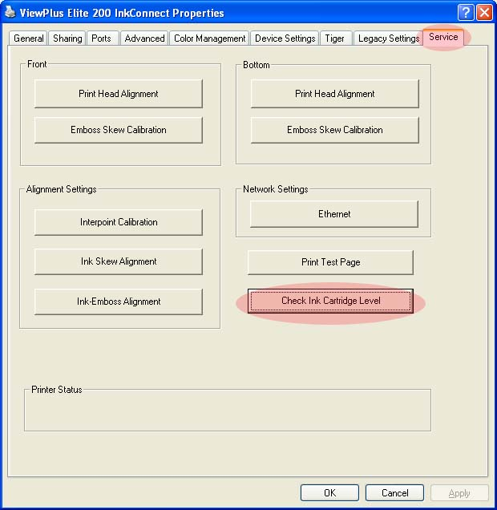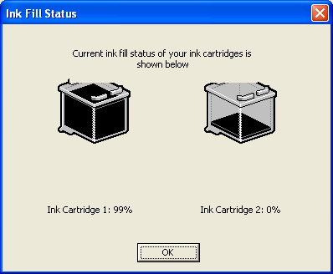

Priming ink cartridge
If the estimated fill of an ink cartridge has not yet reached 0% but the cartridge is failing to print, a simple priming procedure may work. A common scenario when this might occur is if an installed ink cartridge has not been used in several weeks. To prime the cartridge, first remove it from the carriage by pulling at the top of the cartridge and rotating it out. Wet a piece of paper towel and gently wipe the nozzles of the print cartridge in a left to right motion in the orientation of the picture below. Reinstall the cartridge and try printing again.
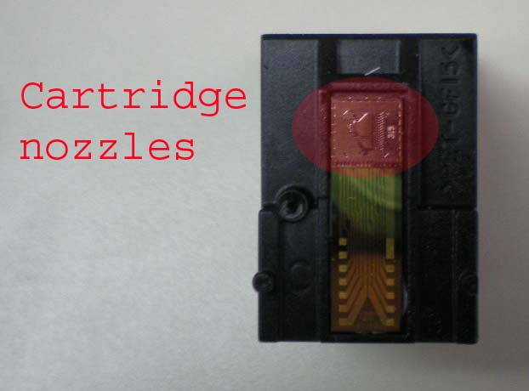
General considerations
It is recommended that the ink cartridges remain sealed in their original packaging until they are ready for use. This will help keep them from becoming dried out prematurely. If cartridges are going to be left unused for an extended period of time, remove them from the InkConnect and place them in a sealed plastic bag for storage. Store the bag such that the nozzles are facing downward and the label is facing upward. It is preferable to store a damp cloth in the bag with the cartridges. It is important that the damp cloth does not touch the cartridge nozzles during storage.
3. Problems with ink output
Ink skew calibration
If the ink printout from the InkConnect is offset in alternating rows, then the skew correction needs to be reset to a better value. An exaggerated example can be seen below. To correct the skew value click the “Ink Skew Alignment” button in the service tab. This prints the ink skew calibration, which allows you to line up the ink printing from one pass of the print head to the next. The pattern is a numbered set of vertical ink lines, one of which is a perfectly straight line. Enter the number of the perfectly straight line into the Ink Skew field.

The picture to the right is a result of a bad skew, when trying to print a vertical line.
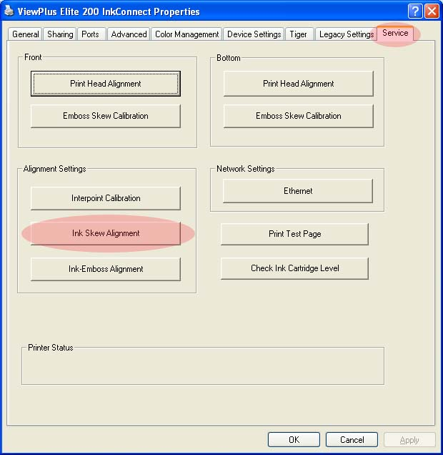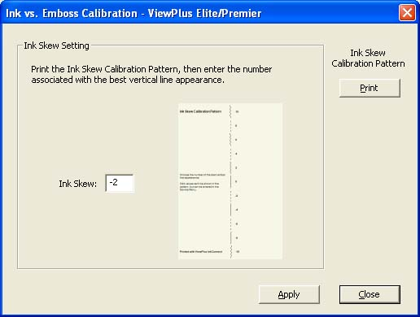
Cartridge spacing setting
If the ink output from the InkConnect looks similar to the ink skew problem, but it only occurs in the middle of the page, then the ink cartridge spacing setting needs to be adjusted. Due to tolerances from cartridge to cartridge the physical spacing between 2 installed cartridges can vary slightly. This variance is what causes the problems with the ink output. To change the ink cartridge spacing setting, click the "cartridge spacing" in the service tab. The pattern is two columns of inked rectangles and a column of numbers from -10 to 10. Select the number of the row in the pattern in which the ink rectangles neither overlap nor have white space between them, and enter it into the Cartridge Spacing field.
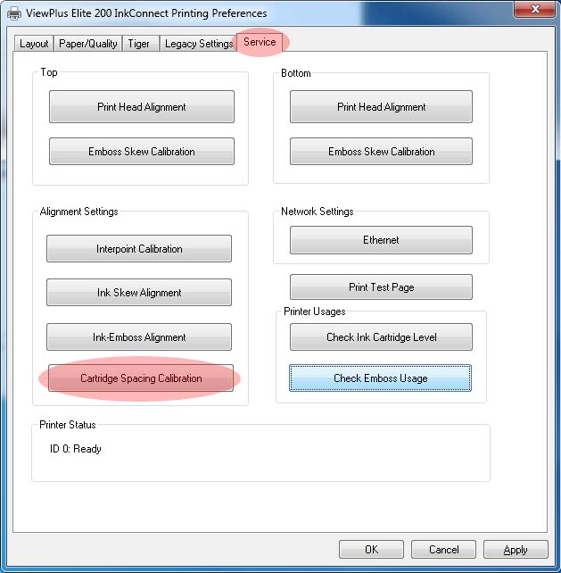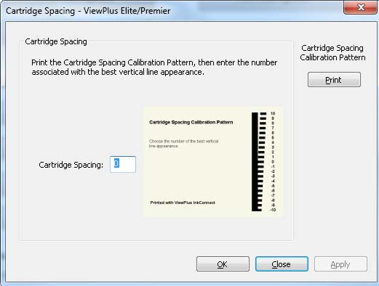

Checking cartridge wipers
If the ink output from the InkConnect becomes blurry or smeared, the cartridge wipers may need to be adjusted. The wipers serve the purpose of periodically wiping off the excess ink that builds up on the print nozzles. A picture below shows the correct wiper position to optimally clean the cartridge nozzles. For instructions on adjusting the wipers see the hardware disassembly/replacement section under carriage.

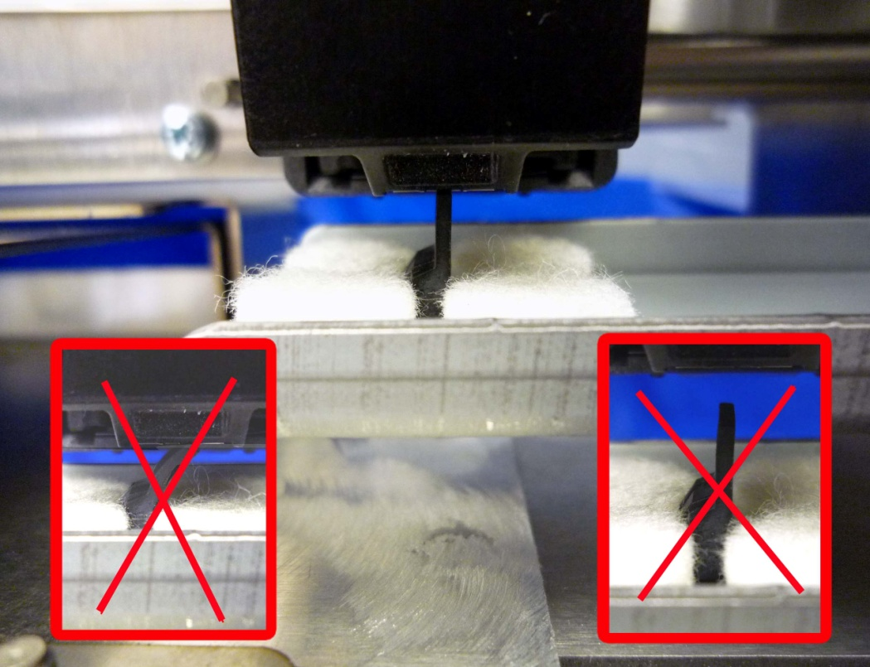

4. Paper jamming
Diagnosing paper jamming
If paper jam problems occur more than rarely they should be addressed. It is first important to determine whether the paper jamming is occurring inside the Elite or Premier embosser or inside the InkConnect.
If the paper never exits the back of the embosser during a print job then the problem is occurring inside the Elite or Premier. This can be checked by looking across the paper guides that lead the paper into the InkConnect from the embosser while printing. If the paper never becomes visible, then the jam has occurred in the embosser. To clear jams of this type the InkConnect must be removed from the back of the embosser (see the “Safe removal/installation of InkConnect” section) then refer to the service manual for the Elite/Premier embosser series.
If the paper makes it through the paper guides leading from the embosser to the InkConnect, but doesn’t exit the InkConnect, then the problem can still be resulting from the embosser. While looking at the paper in the guides exiting the embosser pay special attention to see whether the paper has any creases or large buckles. If this is the case then the jam is a result of what is happening in the embosser; see the Elite/Premier service manual for further instructions. If the paper is jamming inside of the InkConnect, but is coming out of the embosser in a normal fashion, then the paper jam is a result of the InkConnect hardware.
Plastic deflector replacement/adjustment
If paper jamming is occurring in the InkConnect the most likely component to cause the jam is the plastic deflector located underneath the carriage. First evaluate the condition of the plastic guide and note any creases or deformities in the deflector. If the deflector is largely deformed it should be replaced; contact ViewPlus support.
Paper jamming can also occur if the plastic deflector is bent to an incorrect angle. If the deflector is bent too much it can cause problems when the paper is reversed back into the embosser. If the deflector is not bent enough it can allow the paper to jam on the paper guide closest to the back lid on the top. A proper bend of the plastic guide should keep the very end of the deflector just off the lower paper guide. See the picture below for a properly bent plastic deflector. If the deflector is bent incorrectly it can be adjusted in the field by pulling or pushing gently on the guide until the proper angle is achieved.
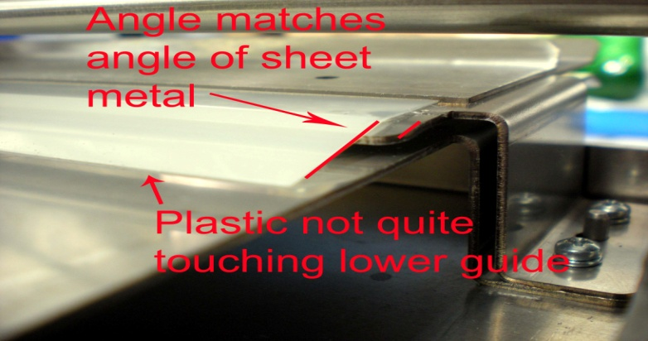
To replace the plastic guide see the hardware disassembly/replacement section for removing the InkConnect case and carriage. This will allow proper access for deflector removal and replacement. To remove the existing plastic deflector grab one corner of the guide and pull up the adhesive attached to the metal piece below. Before placing the replacement deflector, clean the surface with an alcohol based wipe. Remove the paper covering the adhesive on the new deflector and firmly apply to the metal guide as shown in the picture below.
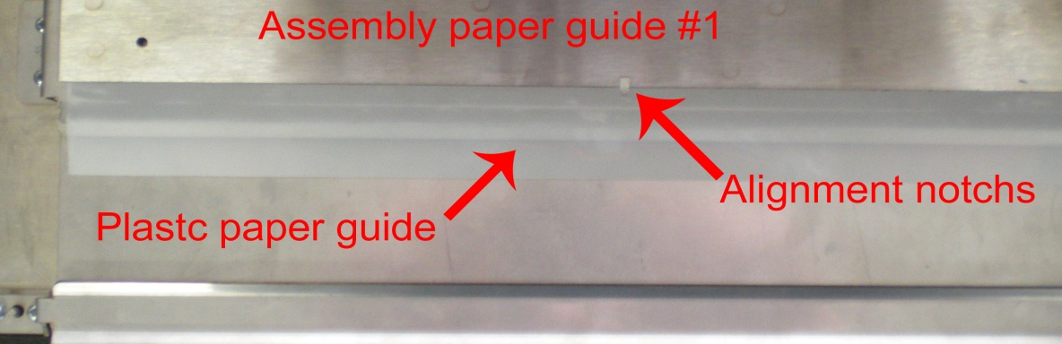

III Hardware disassembly/replacement
This section is designed to describe the hardware disassembly for the purpose of replacement and component access. The steps listed are for hardware removal, to replace a component simply follow the listed steps in reverse order. Any steps taken in this section should result from consulting with ViewPlus support.
1. Case (this section must be completed before all other hardware removal sections)
Identifying case components
Below are 2 pictures showing the InkConnect from 2 different angles. The main components are labeled for reference.
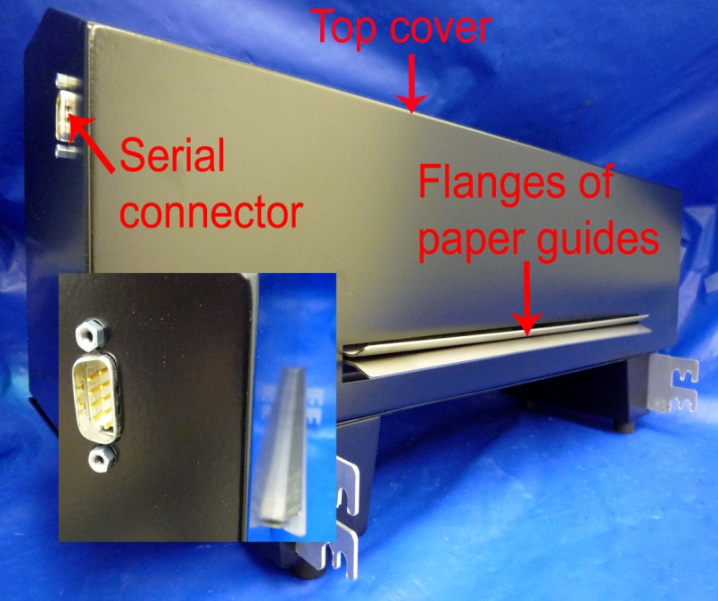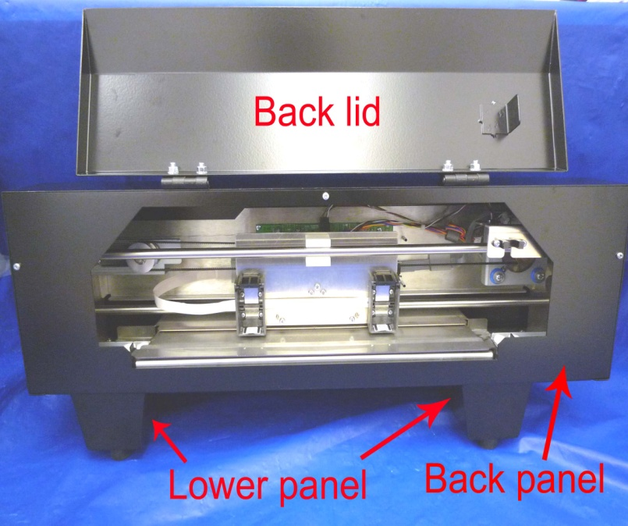
Removing case for service
The first component of the case to remove is the back panel. Rotate the back lid upward to gain access to a covered screw, and then remove the 3 M3x6 screws shown in the picture below. When reinstalling these 3 screws use Loctite 222.
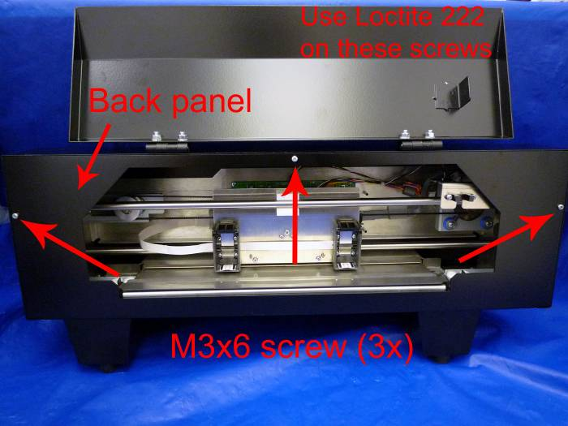
Rotate the InkConnect to allow access to the bottom. Remove 2 M3x6 screws shown in the picture below. Use Loctite 222 when reinstalling these 2 screws. The back panel is now unattached for removal.
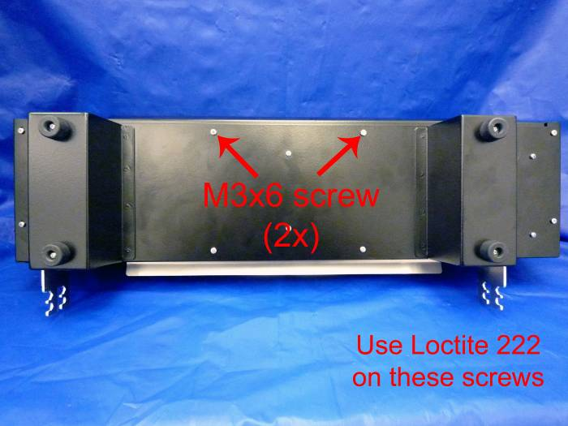
It should be noted that the back lid will remain attached to the top cover when it is removed. The second component to remove is the top cover. Rotate the InkConnect to allow access to the bottom. Remove 6 M3x6 screws shown in the picture below. Use Loctite 222 when reinstalling these 6 screws.
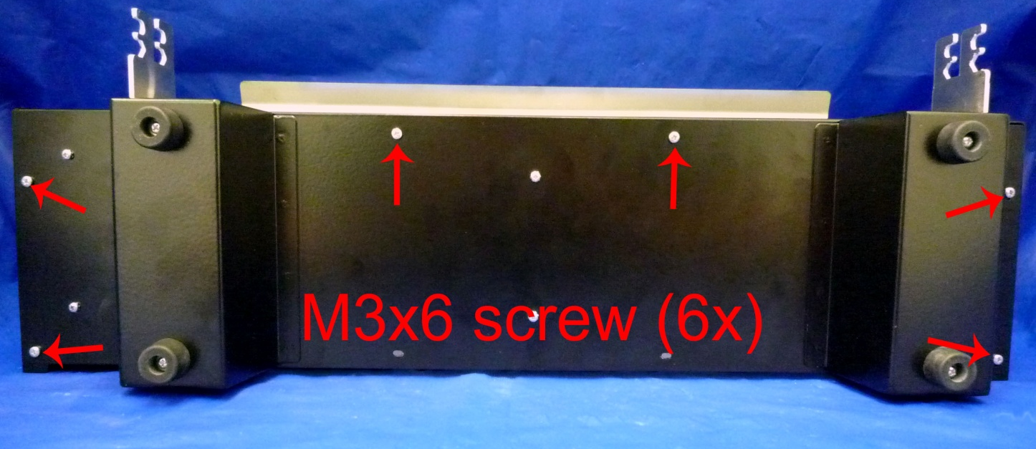
The top cover is now detached for removal. To remove the top cover slide it to the side so that the serial port goes inside the case, then slide the case forward over the paper guide flanges shown in the picture on the previous page.

2. Carriage assembly
Identifying carriage components
Below are 2 pictures of the carriage from 2 different angles. They contain labels identifying the critical carriage components. The pictures are shown with the carriage removed from the InkConnect for clarity.
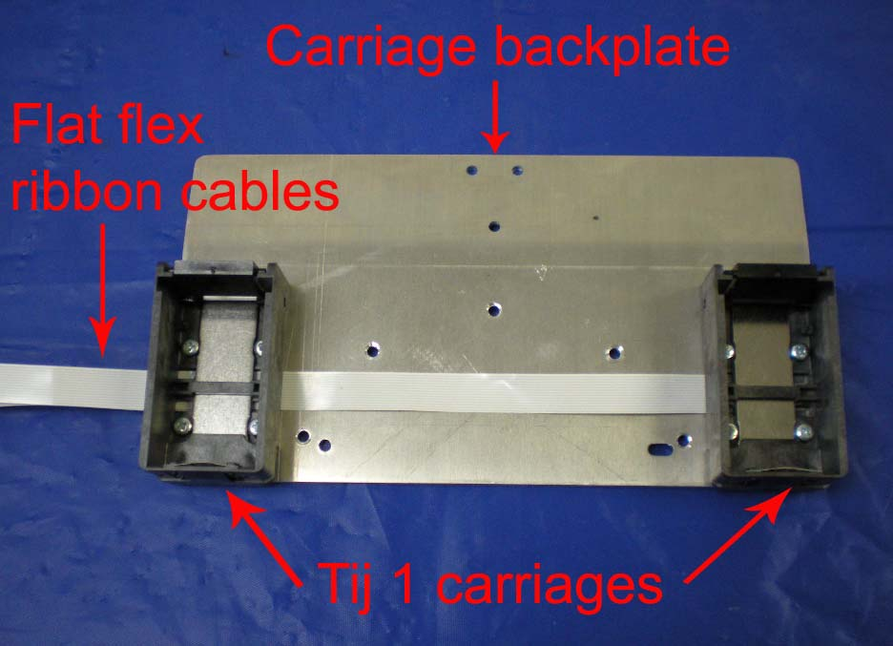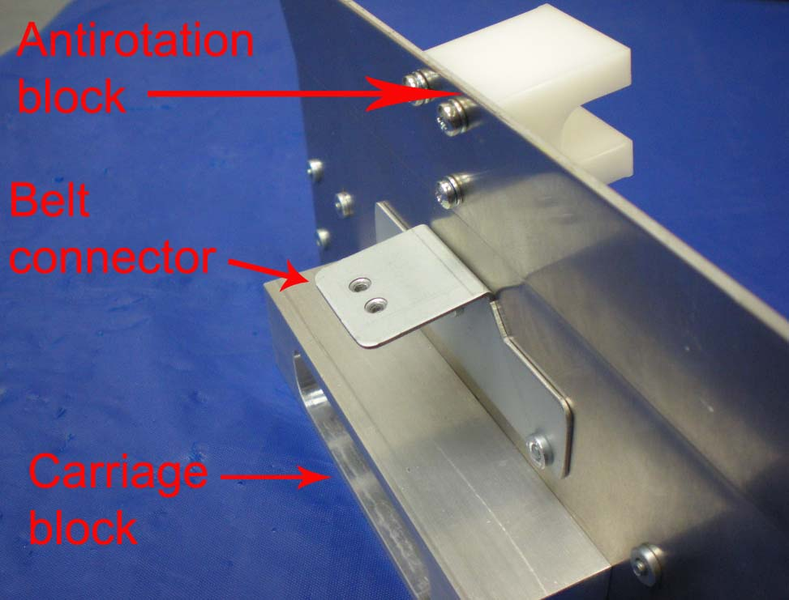
Removing the carriage assembly
Remove the 2 M3x10 flathead screws shown in the picture below that attach the belt clamp to the carriage. Use Loctite 222 when reinstalling these 2 screws.
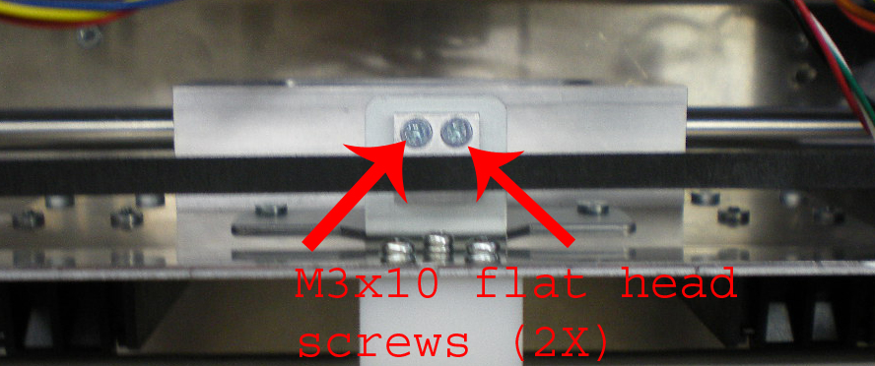

Remove the 4 M3x12 screws with lock washers shown in the picture below that attach the electronics cover the main frame. The carriage will have to be moved to access all of the screws.
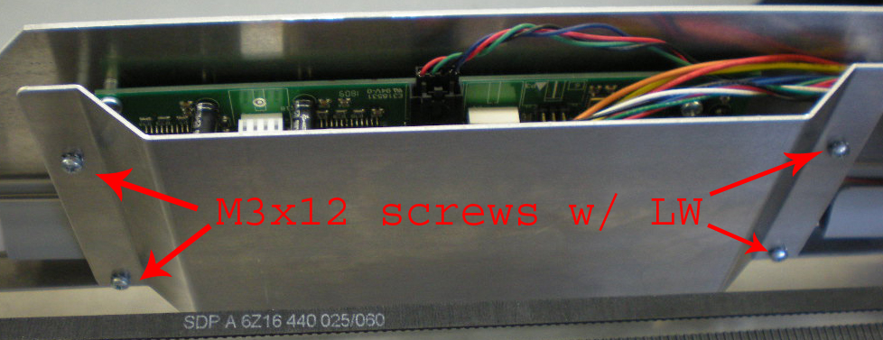
On the circuit board release the flat-flex ribbon cables by pulling the 2 locking tabs for each cable outward. Remove both cables from the cable clip installed next to the board (shown in the picture below).
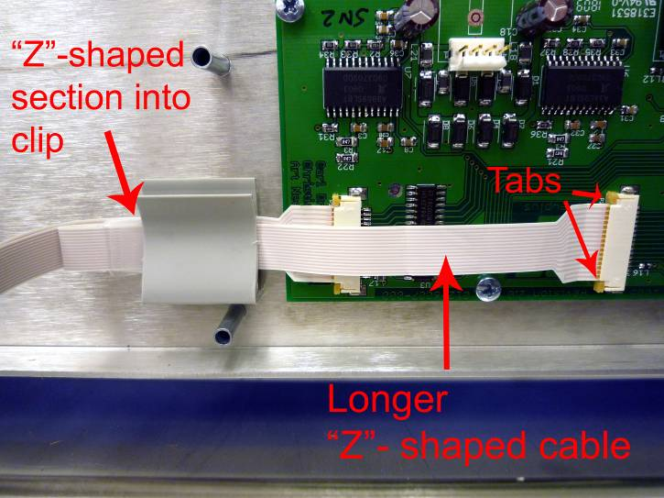

Remove the right frame stiffener plate by taking out all screws on that side of the main frame (9 M3x8 screws with lock washer & 2 M4x10 screws with lock washer). Removing these screws will detach the motor mount and one of the wiper plates from the frame. Leave these 2 components laying inside the InkConnect below where they were mounted.
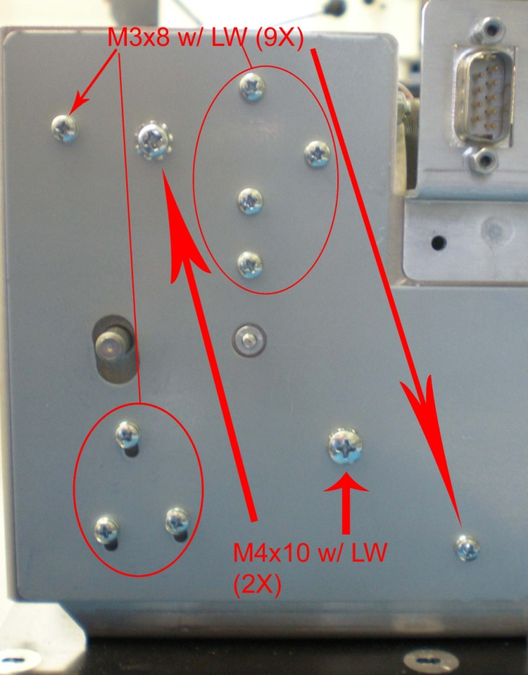
Remove the 2 M4x10 screws with lock washers shown in the picture below that attach the antirotation shaft and the carriage shaft to the frame. Remove the shafts from the frame by sliding them out the opposite side (the side where the right frame stiffener plate was removed).
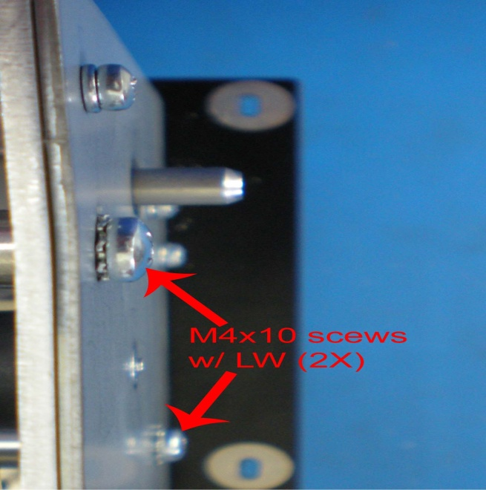

3. Drive motor, belt and tensioning assembly
Identifying belt drive and tensioning components
Below are 2 pictures identifying the components of the belt drive and tensioning system in the InkConnect.
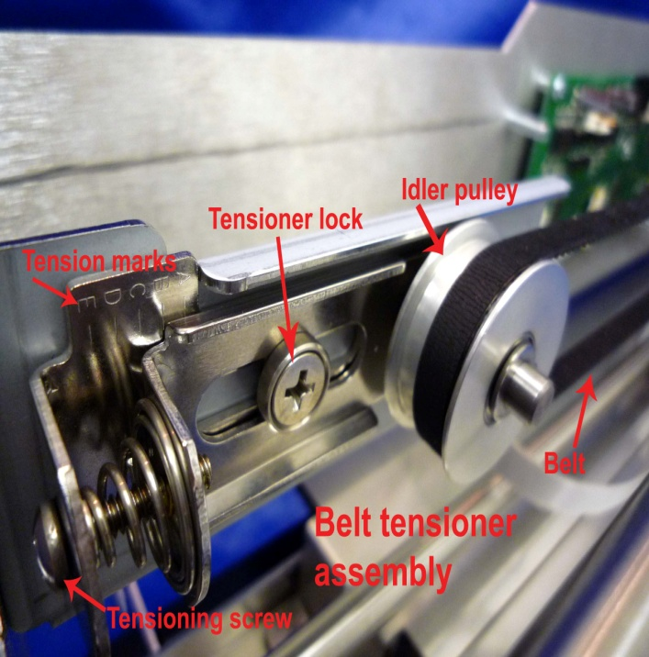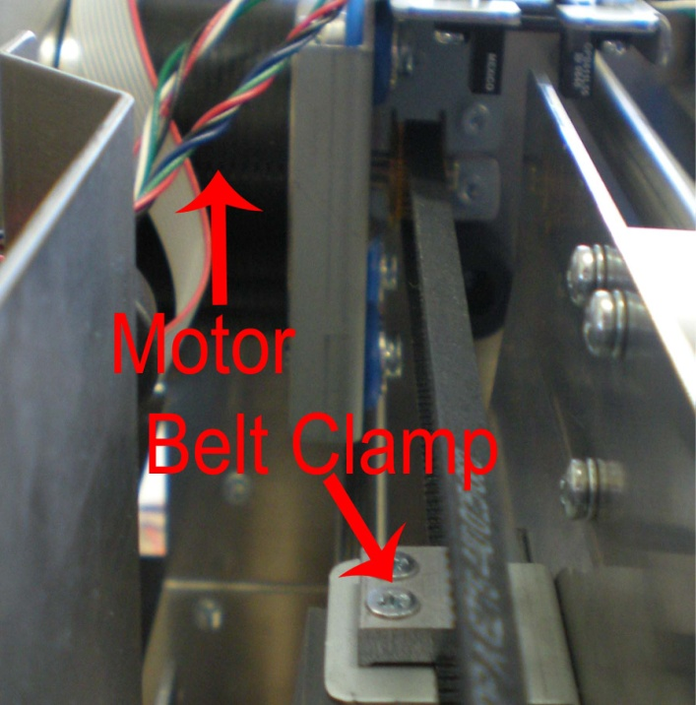
Tensioning the belt properly
The carriage belt of the InkConnect is tensioned against a spring system to ensure correct and consistent belt tension from unit to unit. Once tension is set against the spring, the system is then locked down to keep the tension constant. Below is a picture of the belt tensioning system, showing both the tensioning and locking screws. The appropriate tension in the belt corresponds to the tension indicator being located on the “D” mark stamped into the sheet metal.
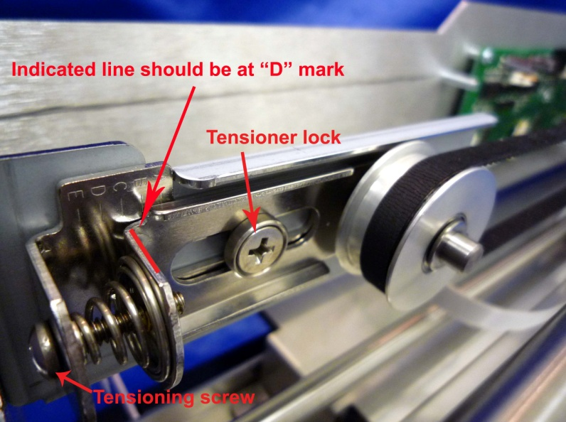

Removing belt tensioning assembly
To remove the belt tensioning assembly, first loosen the locking screw on the belt tensioner. Next loosen the tensioning screw on the assembly until the carriage belt can be easily removed. With the belt off the tensioner, remove the 3 M3x8 screws with lock washer holding the belt tensioner assembly to the frame. The screws to remove can be seen in the picture below.
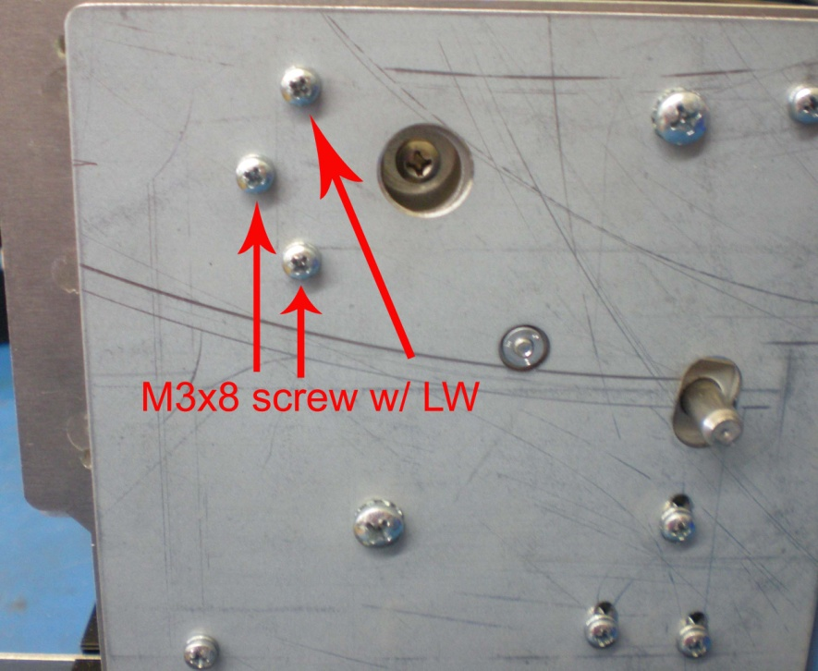
Motor replacement
Loosen the belt as per the instructions in the “Removing belt tensioning assembly” section. Unplug the motor cable from the motor. Remove the 4 M3x8 screws with lock washers shown in the picture below that hold the motor mount to the frame. Carefully rotate the motor mount and remove the 2 M3x6 screws holding the homeflag sensor to the motor mount. Place the sensor carefully down in the frame and take out the motor mount with the motor attached.

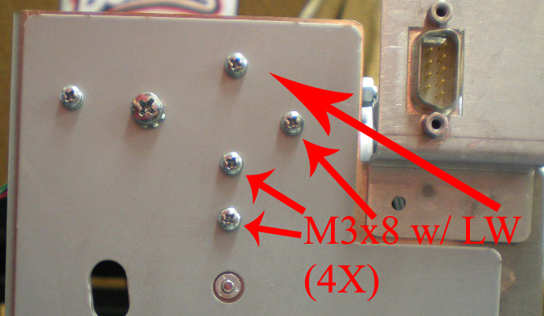
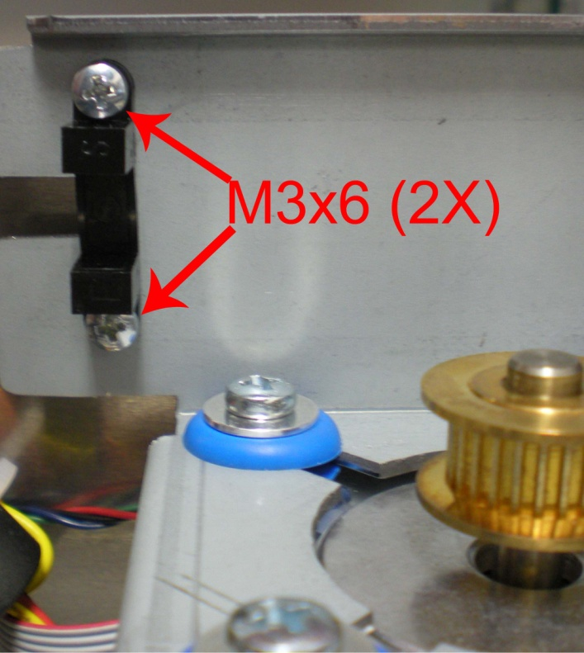
To take out the motor from the motor mount, remove the 4 M4x18 screws shown in the picture below by unscrewing them from the locknuts attached on the back.
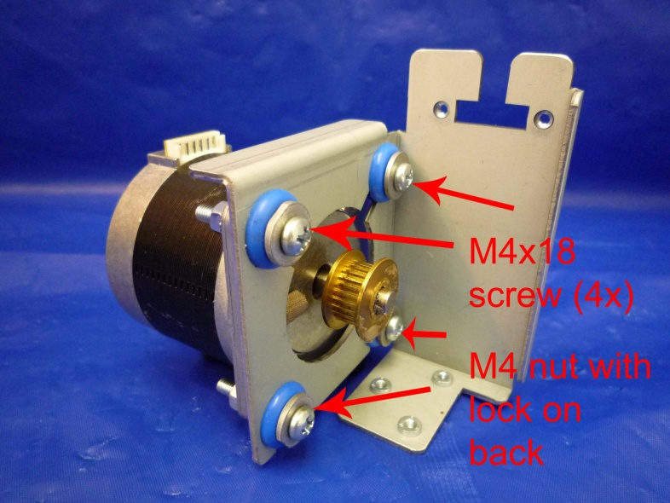

4. Electronics
Electronic component identification
Below is a picture of the main board identifying the electronic component plug-ins of the InkConnect. The electronics cover and cables have been removed for the purpose of clarity.
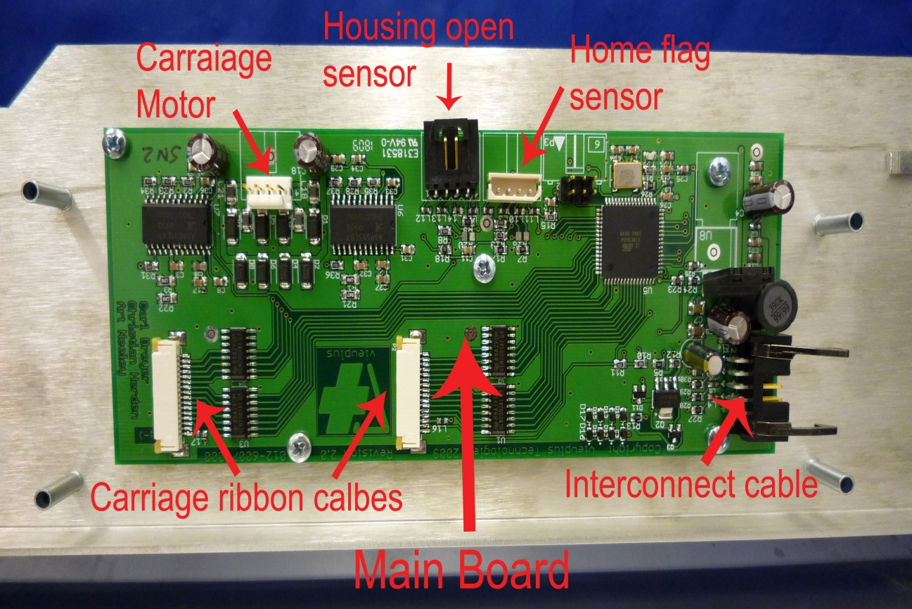
Replacing the main board
Remove the 4 M3x12 screws with lock washers shown in the picture below that attach the electronics cover to the main frame. The carriage will have to be moved to access all of the screws.

Unplug all cables attached to the circuit board. To unplug the flat flex ribbon cables, pull the 2 plastic tabs away from the connector. To unplug the interconnect cable, lift the 2 prongs. Remove the 5 M3x6 screws shown in the picture below that attach the board to the frame (parts have been removed for clarity purposes). Remove the circuit board from the InkConnect.
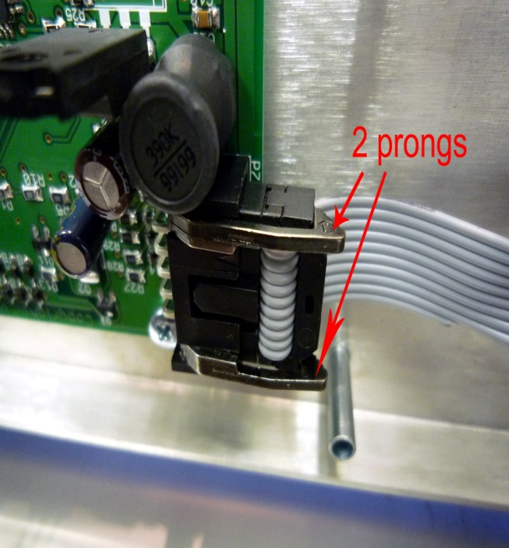
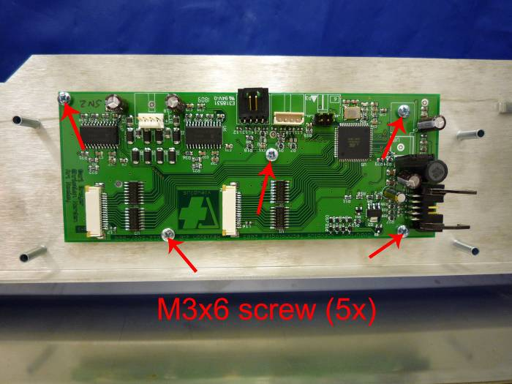

Replacing the case sensor
Remove the 4 M3x12 screws with lock washers shown in the picture below that attach the electronics cover to the main frame. The carriage will have to be moved to access all of the screws.
Unplug the case sensor from the main circuit board, then remove the 2 M3x6 screws shown in the picture below that attach the case sensor to the main frame.
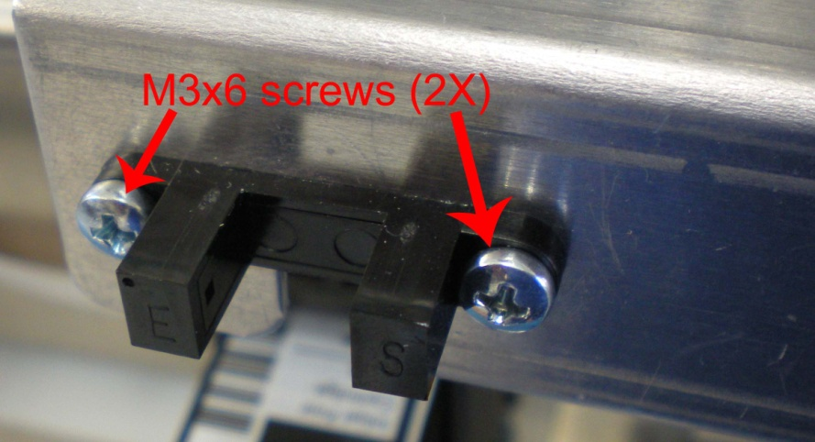

Replacing the home flag sensor
Remove the 4 M3x12 screws with lock washers shown in the picture below that attach the electronics cover to the main frame. The carriage will have to be moved to access all of the screws.
Loosen the belt as per the instructions in the “Removing belt tensioning assembly” section. Unplug the motor cable from the motor. Remove the 4 M3x8 screws with lock washers shown in the picture below that hold the motor mount to the frame. Carefully rotate the motor mount and remove the 2 M3x6 screws holding the homeflag sensor to the motor mount. Place the sensor carefully down in the frame and take out the motor mount with the motor attached. Unplug the home flag sensor from the circuit board and remove it from the InkConnect.

Replacing the flat flex ribbon cables
Remove the 4 M3x12 screws with lock washers shown in the picture below that attach the electronics cover to the main frame. The carriage will have to be moved to access all of the screws.
Unplug the flat-flex ribbon cables from the circuit board by pulling the plastic tabs away from the connector. The tabs are shown in the picture below. Remove the cables from the cable clip located next to the circuit board.

Remove the ink cartridges from the carriage. Loosen the TIJ 1 carriages by unscrewing a total of 8 M2.5x6 screws. Remember to use Loctite 222 when reinstalling these screws. Remove the TIJ 1 carriages along with the flat-flex ribbon cables attached to them. Take special notice of the cable folding and routing as it will have to be recreated when installing new TIJ 1 carriages.
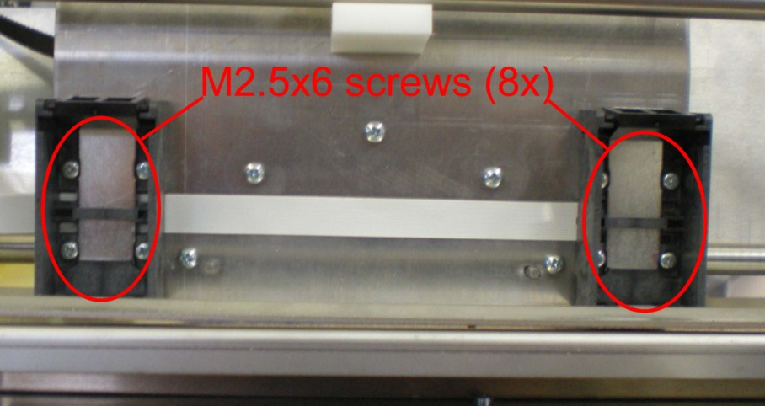
Replacing interconnect cable
Remove the 4 M3x12 screws with lock washers shown in the picture below that attach the electronics cover to the main frame. The carriage will have to be moved to access all of the screws.

Unplug the interconnect cable from the circuit board by lifting the 2 prongs shown in the picture below that hold it into the connector. Remove the cable from the cable clip located next to the circuit board.
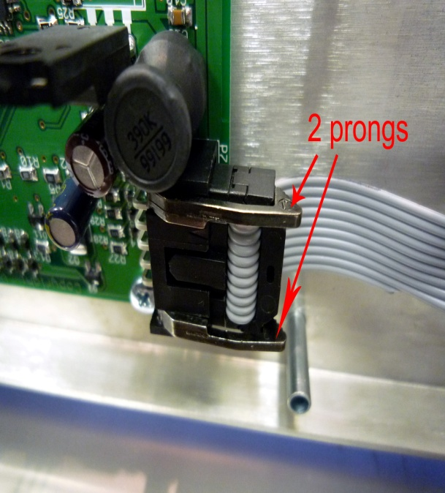
Unscrew the 2 hex standoffs shown in the picture below that hold the interconnect cable to the frame. Remember to use Loctite 222 on these standoffs when reinstalling them. Preferably, use a 5mm hex socket to unscrew the standoffs. Pliers are an acceptable replacement for the hex socket, but special care should be taken to ensure that the standoffs are not damaged. Remove the interconnect cable from the InkConnect.
