Desktop Gen 2 Series Braille Embossers
ViewPlus Cub
ViewPlus Max

Service Manual

Version 2.3
05/11/2015
 |  | Desktop troubleshooting guide
General Problem: | Specific Symptom: | Probable Cause: | Next Probable Cause: | Next Probable Cause:
If the printer is not turning on | Check to see if you can hear a buzzing sound from the area of the power supply when you turn the printer on. You may need to take the case off to hear properly. | If you can hear the power supply come on, replace the mainboard. See Section 19.1. If you cannot hear the power supply check the fuses first. See section 8.1. | If the fuses are okay, replace power supply. See section 12.1.
If the printer starts to pull up paper, then stops and errors out. | Replace the alignment sensor. See Section 9.1. Make sure you have the correct alignment sensor type. | Replace the carriage block, alignment sensor and paper guide, transfer the solenoids over to the new block. | Replace the mainboard. See Section 19.1
If the printer is not embossing | Check to see if the unit is turning on. Check to see if the lights on the mainboard are coming on (you can see them on the operator panel). | Try printing with the unit. Does the printer do anything? If it tries to print but errors out, Change the alignments sensor. See section 9.1. | If the alignment sensor didn’t work, make sure that the housing switch and home flag sensor are functioning. | If the printer doesn’t try to print at all change the mainboard. See section 19.1.
 |  | If no lights come on at all replace the mainboard. See section 19.1. | If changing the mainboard did not work change the power supply. See section 21.1.
 | Check to make sure that the tractor is in place. | If it is not, reinstall the tractor.
If the printer is tearing paper | Use the calibration verification page to see which of the solenoids are tearing paper. | Replace the solenoids that are tearing, it might be all of them. See section 12.1. | If it still tears paper then make sure that the paper guide is tight against the platen. If it is not then replace it. See section 14.1.
 | Make sure the printer has the new paper deflector and not the old plastic strip. | If the printer has the old plastic strip change it out for the new deflector. See section 18.1.
If the printer is not communicating with the computer | Make sure it is not something wrong with the computer or drivers first. | Test the USB port by opening the toolbox. If the toolbox pulls information from the printer than the USB port is functioning. If it doesn’t pull information off then replace the mainboard. See section 19.1.
If there is a verticle void in the printing | See section 6 for instructions on how to determine if the void is caused by the board or the solenoid. | If it is the solenoid see section 12.1 to replace the solenoid or section 19.1 to replace the mainboard.
If the printer will not find top of form | Update the firmware to the newest avalible version.
If the printer drops the paper out of the back of the printer | Update the firmware to the newest avalible version.
If the printer 'shudders' in pulling the paper up to print or the unit will not work in single sheet feed mode. | You may be stuck in single sheet feed or tractor mode. Check the paper path switch on the top of the unit. | If it has tractor selected, use the toolbox to check the switch. If it is stuck in one mode or the other remove the mechanical assembly (See Section 16.1) and see if either the switch fell off or there is a cable blocking the switch.
If the dots are out of aligment vertically and change how much they are out of alignment over the course of the page. | Check to see if one of the platen belts has missing teeth or a streched spot. | Check the tension of the platen belts. The platen belt connecting directly to the platen should be very tight. The platen belt going from the motor to the gear box should be tight. | Replace the mainboard. See Section 19.1
Customer is complaining that their tractor keeps popping out of place. | Add tractor retainer. Call Viewplus support to purchase one.

Table of Contents
Tools Required: 7
1. Introduction 8
Conventions used in this Manual 8
2. Service Preparation 8
3. Repair Procedures 8
3.1 Initial Printer Setup 8
3.2 Dot Alignment 21
3.3 Print Skew Calibration 26
3.4 Solenoid Calibration 30
3.5 Fine Tuning 32
4. Checking the Solenoid Wiring 37
5. Replacing the Case 38
5.1 Removing the Case 38
5.2 Replacing the Case 41
6. Checking if a Blank Column is the Solenoid or Board 43
7. Checking the Gears for Slippage 44
8. Checking the Fuse 46
9. Replacing the Alignment Sensor 47
9.1 Removing Alignment Sensor 47
9.2 Replacing the Alignment Sensor 48
10. Replacing the Platen 48
10.1 Removing the Platen 48
10.2 Replacing Platen 51
11. Replacing the Platen Motor Assembly 55
11.1 Removing the Platen Motor Assembly 55
11.2 Replacing the Platen Motor Assembly 57
12. Replacing a Solenoid 60
12.1 Removing the solenoid 60
12.2 Replacing a Solenoid 61
13. Replacing the Carriage 63
13.1 Removing the Carriage 63
13.2 Replacing the Carriage 66
14. Replacing the Carriage Paper Guide 69
14.1 Removing the Paper Guide 69
14.2 Replacing the Paper Guide 70
15. Replacing the Interconnect Board 70
15.1 Removing the Interconnect Board 71
15.2 Replacing the Interconnect Board 72
16. Replacing the Mechanical Assembly 72
16.1 Removing the Mechanical Assembly 72
16.2 Replacing the Mechanical Assembly 75
17. Replacing the Ribbon Cables 77
17.1 Removing the Ribbon Cables 77
17.2 Replacing the Ribbon Cables 77
18. Replacing the Plastic Strip with the Paper Deflector 78
18.1 Removing the Plastic Strip 78
18.2 Installing the Paper Deflector 80
19. Replacing the Mainboard 82
19.1 Removing the Mainboard 83
19.2 Replacing the Mainboard 84
20. Replacing the Single Sheet Feed Sensor 91
20.1 Removing the Single Sheet Feed Sensor 91
20.2 Replacing the Single Sheet Feed Sensor 93
21. Replacing the Power Supply 94
21.1 Removing the Power Supply 94
21.2 Replacing the Power Supply 94

Tools Required:

#2 Phillips Screwdriver
#3 Phillips Screwdriver
#1 Flathead Screwdriver
2.5mm Hex Key (Allen wrench)
A-150 E-Ring tool
½” Flat Open-ended Wrench
Pliers
Wire Cutters
5.5mm Hex driver
Digital Multi-Meter

1. Introduction
This manual is to be used in conjunction with the Desktop Gen 2 Operator’s manual.

Construction overview of the Gen 2 Desktop series embossers

The Desktop Series Embossers are built around a highly modified high quality dot matrix printer base. This provides a proven paper handling system and high quality mechanical platform of known durability.

Note: The length of some screws is critical. If a screw is to be replaced, use a screw of equivalent type and length. Torque specifications for any location, regardless of length, is as follows: M2.5 screws at 48in/oz, M3 screws at 80in/oz, M4 screws at 96in/oz and all screws in plastic at 48in/oz.

Conventions used in this Manual
To minimize confusion, several conventions are used in this manual.

Unless noted otherwise, the terms front, back, left and right will be from the perspective of an operator at the tractor of the unit.

Observe the general safety precautions outlined in the Operator’s manual.
CAUTION: Dangerous Voltages are present in the embosser if it is connected to a power source.

2. Service Preparation

Note the serial number of the embosser. This number is located on the label located above the power plug on the back of the case, and is used by ViewPlus® to keep a service history of the particular unit.

Inspect the exterior of the embosser and note any damage that may have occurred during shipping.

Determine the firmware version currently loaded on the printer.

3. Repair Procedures

Evaluate if the problem requires you to take the case off. Problems that do not need the case taken off are: If one of the solenoids has stopped firing, if the alignment sensor is not reading or if the unit is tearing paper.

3.1 Initial Printer Setup
If you are aligning a new board the entire alignment process will need to be done. If you have replaced the alignment sensor only then just the threshold calibration will need to be done along with adjusting the alignment if it needs it. For Cub or Cub Jr. printers, use 8.5” X 11” tractor paper. For Max printers use 11.5” X 11” tractor paper. To align the printer with the case off you will need to tape the housing switch down using non-conductive tape. DO NOT FORGET TO REMOVE THE TAPE BEFORE REPLACING THE CASE!

If you think at any time that there may be data stuck in the print spooler you can stop and restart the print spooler by clicking on your start menu, then selecting the ‘Run’ feature. Then you type ‘net stop spooler’ into the text box without the ‘ and click okay. Wait a few seconds until you see a dos window pop up then close. Then open the run feature again and type ‘net start spooler’ and click okay. Once the dos window pops up and disappears the data should be removed from the spooler and you can try printing again.

- Plug in the unit and turn it on. New boards may beep three times and then give a low beep and the orange light will stay on. When this happens, turn the printer off. Hold down the two outside buttons on the mainboard and turn the machine on again.
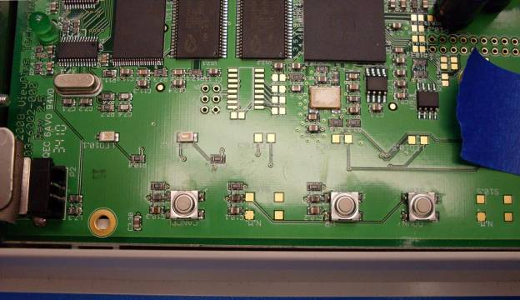
Hold down

- Keep holding the buttons down and it will beep three times, pauses and beeps one long beep and one short beep. Both the green and orange light should be on solid.
- Release the buttons and turn the unit back off.
- Turn the printer back on again and it should give you three beeps and a solid green light.
- Open the toolbox, choose your desktop driver and click ‘OK’. Note: you can use a cub or Jr. printer on the Max driver.

- Once the toolbox opens, check the firmware version to make sure you have the most up to date (2.0 Rev 26). Note: If you have version 2.0.23 or earlier, you probably have a plastic strip instead of a metal paper deflector. That will need to be changed out. If you have already done this, make sure you update the firmware before aligning.
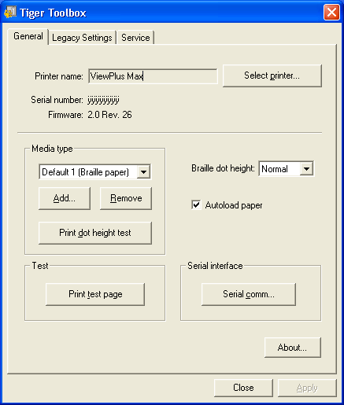

- To update the firmware, turn the unit off. Then hold down all three buttons on the mainboard and turn the unit on while still holding down the buttons.
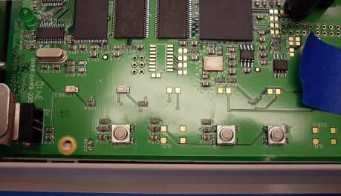
Hold down

- Open the .exe file ‘ViewPlus Desktop Firmware 2.0.26.exe’ and click the ‘Start Download’ button.
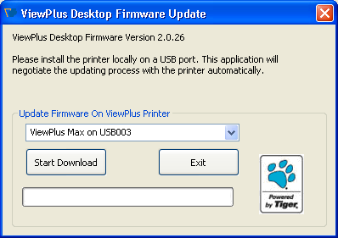

- When the download is finished it will give you a popup window saying that the update was successful.
- Cycle the power and reopen the toolbox.
- Click on the ‘Service’ tab. Click ‘OK’ on the warning message window that pops up.

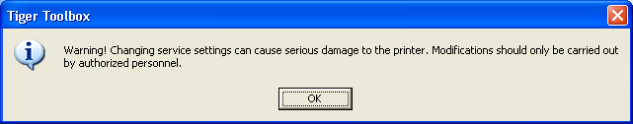

- If you have upgraded from a plastic strip to a paper deflector or put in a new mainboard you will first need to put the serial number in. Click on the ‘Serial number’ button.
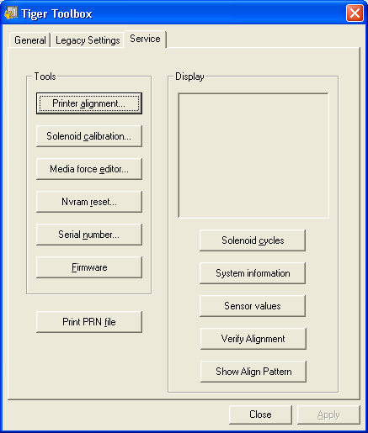

- Enter the serial number into the box adding an A onto the end. If you forget the A you will have a hard time getting the skew to look decent. You can locate the serial number on the serial number sticker on the side of the machine. Click ‘OK’.
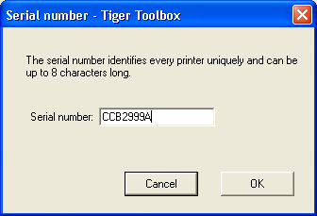

- Click on the ‘Printer alignment’ button. A small pop-up window will appear, no action need be taken.

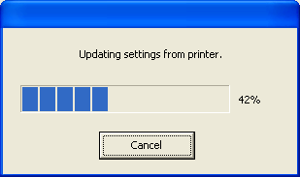

- If the window looks like the one below you will need to reset the Non-volatile RAM. Click ‘Cancel’ on the alignment window.
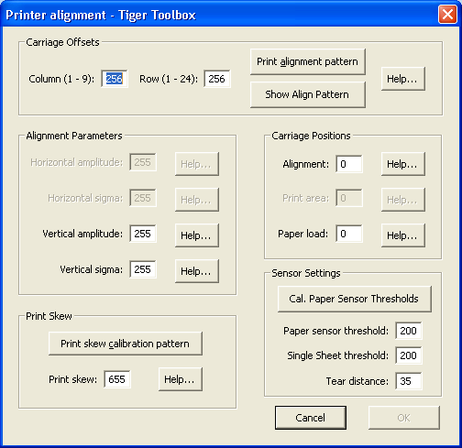

- Click on the ‘nvram reset’ button.

- Click on the ‘Level 3 defaults’ button.
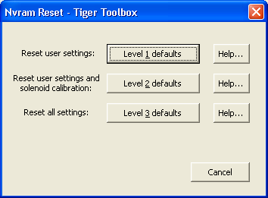

- The printer will beep three times. Then click the ‘Cancel’ button.

- Click on the ‘Printer alignment’ button.
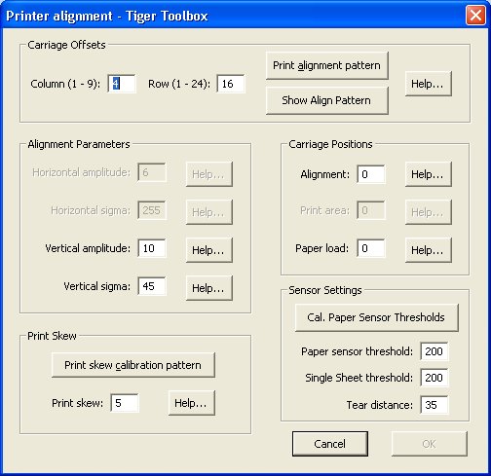

- Take a piece of copy paper and insert it between the paper pan and paper bail and click the ‘Cal. Paper Senor Threshold’ button. The printer will pull the paper through it.

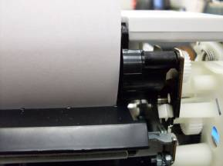

- After the printer ejects the paper, click the ‘Cancel’ button in the printer alignment window.

- Click the ‘Printer alignment’ button. The numbers in the ‘Paper sensor threshold’ and ‘Single sheet threshold’ boxes should have changed from 200 to a value between 90 and 190.
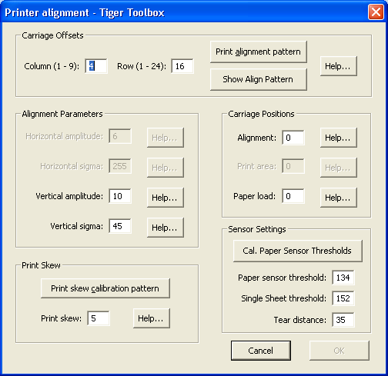
Between 90 and 190

3.2 Dot Alignment

- Place a piece of paper in the tractor of the machine and click on the ‘Print alignment pattern’ button. From now on you will need to place a piece of paper in the tractor every time you are going to print something.

- A pop-up window will appear, click ‘OK’.
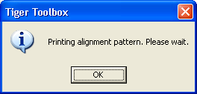

- The printer will print a rectangle of dots.

- From the pattern choose the best looking dot. The ideal dot has four points in the corners and an X going through the dot, as below.

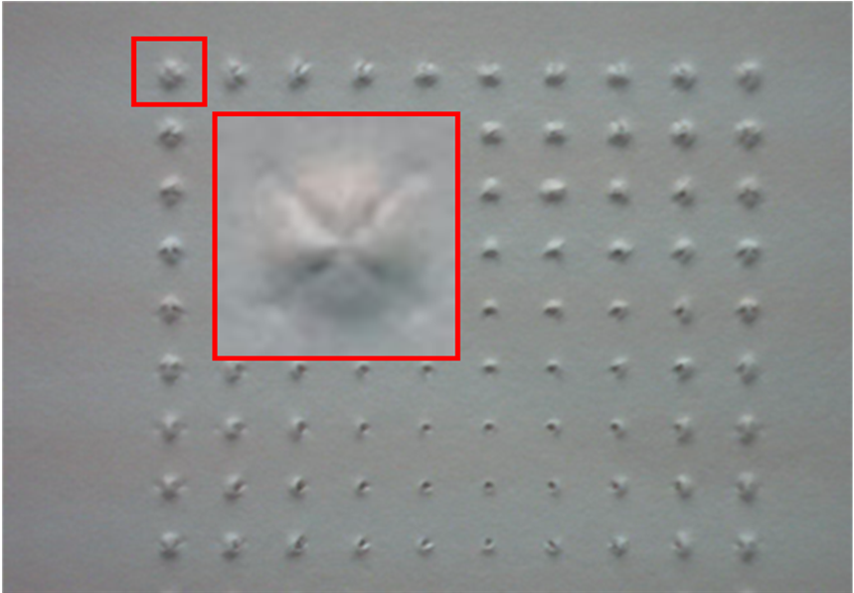

- Once you have chosen your dot, count over horizontally from left to right and put that number into the column box of the ‘Printer alignment’ window. (In the picture above it would be 1).

- Next count down vertically from top to bottom and enter that number into the row box. (In the picture it would also be 1).

- Click the ‘OK’ button.

3.3 Print Skew Calibration
- Click on the ‘Printer alignment’ button.

- Click on the ‘Print skew calibration pattern’ button.

- The printer will print a series of vertical lines of varying straightness.

- Choose the straightest line and count from left to right and enter that number into the ‘Print skew’ box.
Straightest line

8

- Click ‘OK’.

3.4 Solenoid Calibration
- Click on the ‘Solenoid calibration’ button.

- Enter the number 5 into all the solenoid boxes and click ‘Ok’.
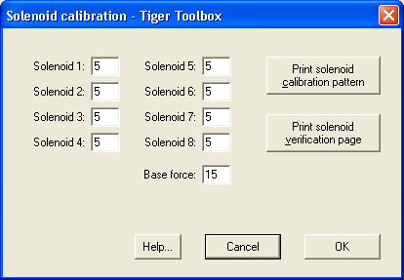

- Print ‘CalVerCUB.prn’ if you have a Cub or Jr. or ‘CalVerMAX.prn’ for a Max. Once the unit is done printing look at the printout and adjust the solenoid calibration up or down by adding 1 to the number for that solenoid to make it punch harder or subtracting 1 from the number to make it punch lighter (clicking ‘OK’ between prints) until all the columns are printing the same or close to the same all the way across the page.
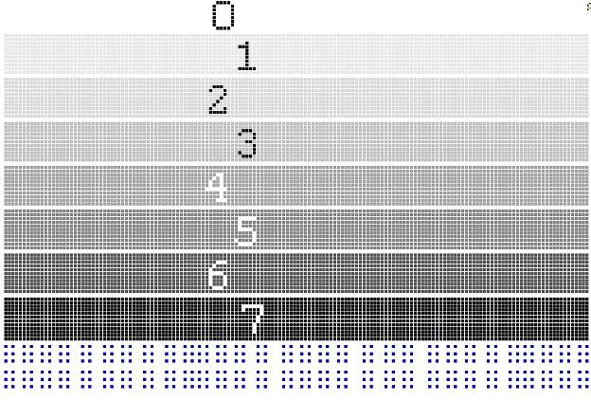

3.5 Fine Tuning
- For the Max look up in the right corner.
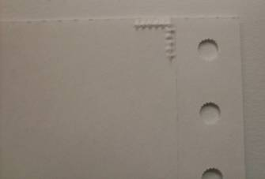

- If the edge of the corner mark is away from or over on to the tractor strip click on the ‘Printer alignment’ button.

- Change the number in the ‘Paper load’ box.

- Click ‘OK’ and continue to adjust it until it lines up with the edge of the tractor strip.

- Next, print a document with a lot of text. Examine the dots to see if you need to adjust the alignment. Below are examples of dots that need adjustment.

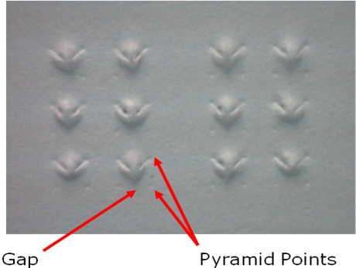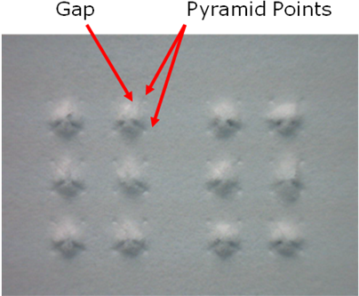
Too low
Too high

Gap
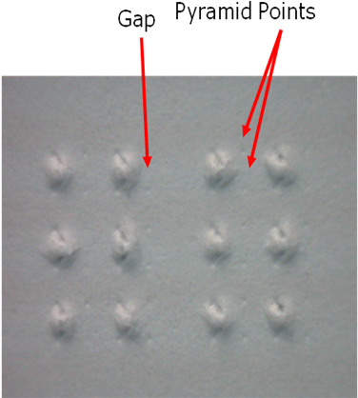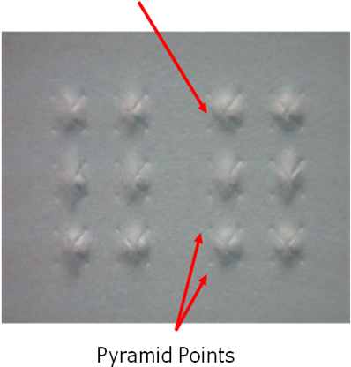
Too far left
Too far right

- To adjust the dots click on the ‘Printer alignment’ button in the toolbox.

 | Moving Dots
Left | Subtract 1 | To Column Number
Right | Add 1 | To Column Number
Up | Subtract 1 | To Row Number
Down | Add 1 | To Row Number

Up or down
Left or right

- Then click ‘OK’ and print the document again. Keep adjusting the dots until they are as good as you can get them.

- Also check the skew on the printout. If the vertical lines down the page are not straight, adjust the skew. Change the number to one up or down from what you currently have it at, then click ‘OK’ and print the document again. Most printers will have a little bit of a skew, adjust the skew until it is as good as you can get it. The skew adjustment is also in the ‘Print alignment’ window with the dot alignment. If you are aligning the printer with the case off: DO NOT FORGET TO REMOVE THE TAPE BEFORE REPLACING THE CASE!
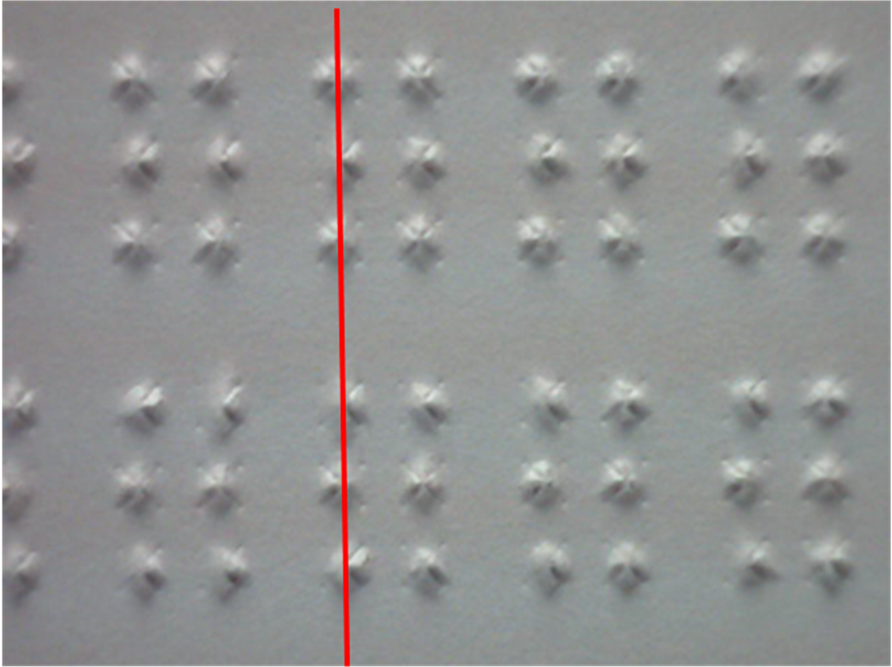

4. Checking the Solenoid Wiring
If one of the solenoids is not firing, check the wires of the solenoids where they plug into the Interconnect board for accuracy and damage.

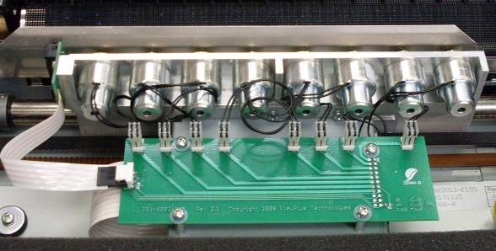
4
5
3
6
7
2
1
8
5
4
6
3
7
2
8
1

Make sure all the wires are free from damage and plugged in correctly. Sometimes they are plugged in backwards or a pin off. If all appears normal then you will need to check and see whether it’s the solenoid that is bad or the motor driver on the mainboard. See Section 6.

5. Replacing the Case
Most of the repairs done on the desktop will need the case removed. There are three models of desktop printer; the Max, the Cub and Cub Jr. The Max is wider than the Cub or Cub Jr. The Cub and Cub Jr. are the same width, the only difference between the two is that the Cub has 8 solenoids and the Cub Jr. has only 4. The Max also has 8 solenoids also, but it is wider to allow for larger paper.

5.1 Removing the Case

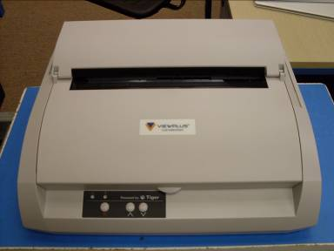

- For all three models, removing the case is done in the same way.
- Lift both pieces of the lid and pull upwards, you may need to swivel the lid back and forth a bit to find the right spot.

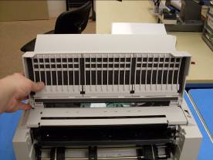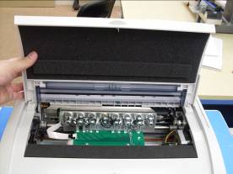

- Remove the M3 plastite screw from the white paper bail on the top of the printer

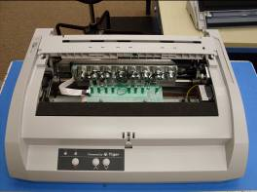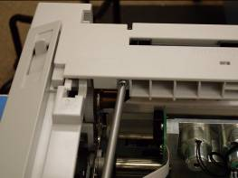
- Remove white paper bail by flipping up the side on which you just took the screw out.

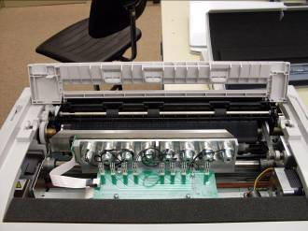

- Pull upwards on the paper bail and it should come out.
- Remove tractor by pulling upwards on the bar closest to you which should pop it out of place then take it out.

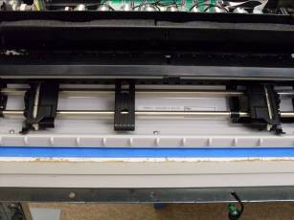

- Remove the three M3 plastite screws from the area where the tractor was.

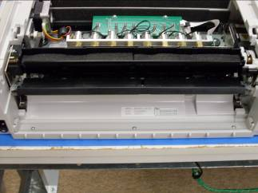
Case Screws

- There are two tabs holding the case on, one on the left side of the tractor area and one on the right.

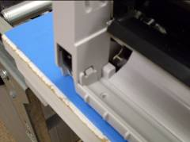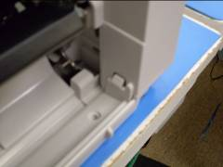

- Using a flathead screwdriver gently depress one of the tabs and pull upward on the top half of the case until the tab cannot go back into the hole. Then holding that side of the case up, gently press the other tab in and the top should pop upward. Then lift the case upwards and off the bottom.

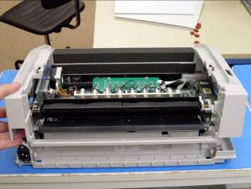

- Remove the black paper bail by removing one M3 plastite screw

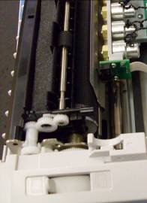
Black Paper Bail Screw

- The case is now off, you may wish to reattach the while paper bail before printing.

5.2 Replacing the Case
- Replace M3 plastite screw into black paper bail.

Black Paper Bail Screw

- Lower the case onto the printer from above being careful not to catch the paper path switch.

- Settle the case down then push down on the front part of the case and it should pop down and sit nicely with the tabs in place in the tractor area.
- Replace the three M3 plastite screws.

Case Screws
- Replace Tractor, making sure that it fully snaps into place.

- Replace white paper bail.

- Replace M3 plastite screw in white paper bail.

- Replace lid.

6. Checking if a Blank Column is the Solenoid or Board
If the printer is printing, but one whole column is blank there is a way to check to and see if it is the solenoid or the board causing the problem. First print the solenoid calibration verification page located under the solenoid calibration button in the toolbox. Unplug the solenoid that matches the blank column and plug it into a neighboring solenoids position.

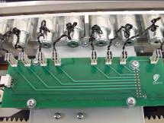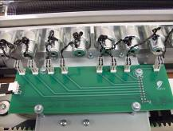
Swap connectors

Plug the neighboring solenoid into the question solenoids position on the Interconnect Board. Print the solenoid calibration verification page. Compare it to the first print. If the blank column is in the same position it is the solenoid that is bad, if the column has moved then it is the mainboard that is bad. To replace the solenoid see Section 12. To replace the mainboard see Section 19.

7. Checking the Gears for Slippage
Occasionally one of the platen gears will come loose. This will cause vertical spacing issues in the print jobs.

- Remove case. See Section 5.1.
- There are three gears that could come loose. One on the end of the platen, and two on the platen motor assembly, one large and one small.

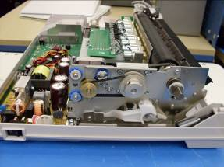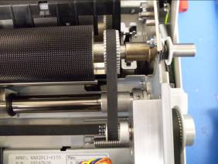
Large Gear
Small Gear
Platen Gear

- Remove the three M3X12 screws with lockwashers (M3X12-BN40100).

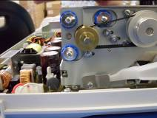
M3X12 Screws

- Remove the belt (230-1084-000) from around the outside gears
- Loosen the 4 M3X8 screws (M3X8-BN384) from the gear block

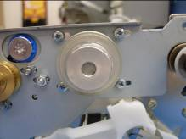
M3X8 Screws

- Remove the inside belt (230-1082-000) from around the small gear
- Take hold of the large gear and pull on it to see if you can pull it off. Do not pull as hard as you can, but give it a good tug. If it doesn’t move then take hold of the small gear at the same time and see if you can twist them in different directions, again, do not do this as hard as you can. If they do not move then try the same thing with the gear on the platen. If all are secure then the problem lies elsewhere.
- If one of the gears is loose then it will need to be removed using the appropriate allen wrench (1.5mm for the large gear and 1.25mm for the small gear) and re-loctited to the shaft. In order to re-loctite the gear on the platen, the platen will need to be removed from the machine. See Section 10.1 and 10.2.
- Let the loctite sit for a few hours to set.
- Replace belt around platen gear and the small pulley.
- Pull the block away from the platen and tighten the screws to tension the belt. Make sure the belt is not too loose or too tight. It should have a little give when you press on it but not very much. If the belt is too loose you will experience vertical shifting problems when you print.

M3X8 Screws

- Replace the outside gear belt around the motor pulley and large gear of the gear block.

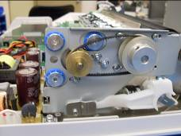
M3X12 Screws

- Replace the three M3X12 screws with lockwashers into the motor. Make sure that the belt is tensioned, it should be a little looser than the inside belt but not so loose as to allow it to skip teeth. To retension the outside platen belt loosen the three M3 nuts (M3-BN1364) using a 5.5mm hexdriver and pull back on the motor, then tighten the nuts.

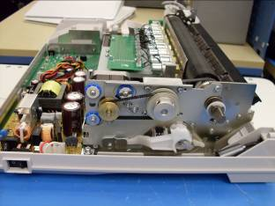
M3 Nuts

- Replace case. See Section 5.2.

8. Checking the Fuse
It often happens that a customer will say that the embosser does not turn on. When this happens you need to check and make sure that the power supply is really not turning on as apposed to the mainboard not coming on. When you turn the unit on you should be able to hear the power supply come on line, it makes an electronic buzzing sound for a second or two. If you cannot hear it come on, then you will need to check the fuse to see if it blew.

- Using a digital multimeter set it to the continuity setting (usually looks like a speaker symbol) and make sure that that it is working by touching the two lead ends together. When the ends are touched together the multimeter should emit a tone.

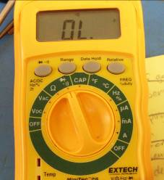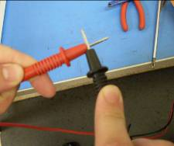
Continuity Function

- Remove the case. See Section 5.1.
- Locate the fuse on the power supply for an older 120v machine the fuse will be clear. For an older 240v machine the fuse will be either all white with a dot or white with colored bands. For the new changeable power supply the fuse is white no matter what. The difference on the changeable ones is that the 120v power supplies have a jumper where as the 240v ones do not.
- To test the fuse turn the Mulitmeter to the continuity setting and place one lead on each end of the fuse, a good fuse will emit a tone from the multimeter, a blown fuse will not.

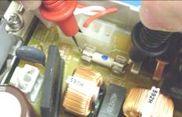

- If the fuse is blown replace it, if not it is probably the mainboard that is blown. See Section 19.
- Replace case. See Section 5.2.

9. Replacing the Alignment Sensor
Faulty alignment sensors can cause a printer to not print. When a print job is sent to the machine, it will move the carriage over to the mirrored portion of the platen and ‘search’ for the mirrors then error out. You can look at the signal the alignment sensor is giving by using the ‘verify alignment’ button in the tool box then clicking the ‘show alignment pattern’ button. The blue and white lines show the pattern, if the sign wave is very low to non-existent then you will need to replace the alignment sensor. You do not need to take the case off to replace the alignment sensor. You will need a very short Philips screwdriver to do this with the case on. After you replace the alignment sensor you will need to run the alignment sensor threshold calibration again. NOTE: Recently we have changed to a new type of alignment sensor. It is in the same place on the carriage, but the screws are in a different orientation. If you need to change from an old style sensor to a new style sensor then you will need to replace not only the sensor but the carriage block and paper guide as well.

9.1 Removing Alignment Sensor

- Remove the lid by lifting each side of it and pulling upwards, you may need to rock the lid back and forth a little to get it to come off.
- Remove the two M2.5X6 screws without lockwasher (M2.5X6-BN384) holding the alignment sensor to the carriage.

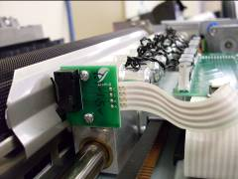
M2.5X6 Screws
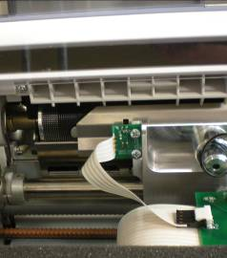
Remove two M3X6 screws without lockwashers with loctite
New Style Sensor

9.2 Replacing the Alignment Sensor
- Replace the alignment sensor with a new one, using the two M2.5X6 screws without lockwasher, but adding loctite 222. For the new style sensor use two M3X6 screws without lockwashers but with loctite 222.
- Plug the alignment sensor into the interconnect board.
- Replace lid.
- Run the threshold calibration in the tool box after replacing the sensor.

10. Replacing the Platen
If the machine is used heavily then the platen may need to be replaced. Generally it is easy to see damage to the platen because the coating on the platen will be worn off and it will look silver on the body of the platen. If you look carefully at the platen sometimes the coating can be worn off, but the pyramids on the platen are not damaged. You will need to re-align the printer after changing the platen.

10.1 Removing the Platen
- Remove case, see Section 5.1.

- Remove the three M3X12 screws with lockwashers (M3X12-BN40100) holding the platen motor in place.

M3X12 Screws

- Remove outside belt and set aside.
- Loosen the four M3X8 screws without lockwashers (M3X8-BN384) going into the gear block.

M3X12 Screws

- Unhook the belt from the small pulley

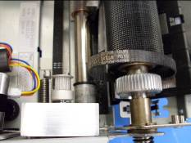
Small Pulley

- Remove large silver E-ring from the right end of the platen.

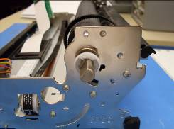
E-Ring

- Remove the large plastic washer, spring (2248-02-06-05), small plastic washer and flanged bearing (2248-02-06-03).

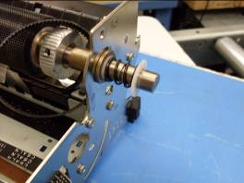
Small Plastic Washer
Flanged Bearing
Large Plastic Washer
Spring

- Remove the large silver E-ring from the other end of the platen.

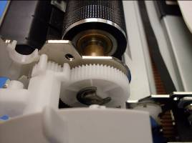
E-ring

- Remove large white gear (2248-02-06-08) and flanged bearing.
Flanged Bearing
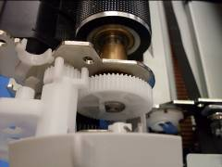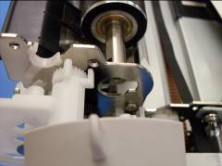
White Gear

- Slide left side of platen out of its hole first, then lift it up and slide the right side out.

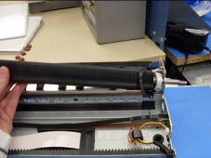

10.2 Replacing Platen
- Put inside platen belt around the gear on the platen
- Slide right side of platen through the hole in the right side of the mechanical assembly.

- Lay the platen flat into the mechanical assembly then slide the left side up to the hole in the left side of the mechanical assembly.

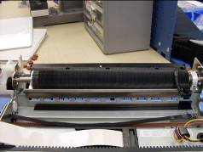

- Slide the flanged bearing through the hole in the left side of the mechanical assembly and around the platen end. Make sure the flanged bearing sits all the way into the side of the mechanical assembly, it fits into a hole exactly the same shape as the bearing.

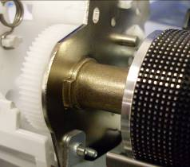

- Slide the platen to the left so that the end of the platen sticks out of the flanged bearing a little bit.

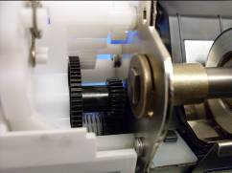

- Line up the flat part of the hole in the white gear to the flat part of the platen end and push the platen to the left through the gear so that the end of the platen is as far as it can go into the gear.

- You should be able to see the groove that the E-ring will fit back into.
- Using the E-ring tool, push the E-ring into the groove on the end of the platen.

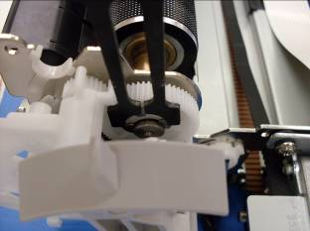

- Replace the flanged bearing, small plastic washer, spring and large plastic washer onto the right end of the platen. It may be difficult to get the flanged bearing to sit into its hole properly, you may have to pull on the platen end a little.

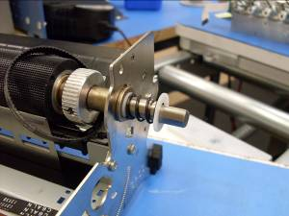

- Using the E-ring tool, push back the plastic washer and spring and sit the E-ring into its groove.

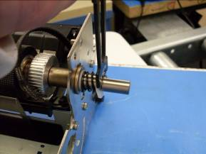

- Situate the inside platen belt over the gear on the platen so that the teeth of the belt fit into the grooves in the gear.
- Hook the other end of the belt over the small pulley on the gear block.

- Pull the block away from the platen and tighten down the four M3X8 screws so the belt is tensioned. The belt should be tight but not so tight that it does not have some give to it when you push on it.
- Put the outside platen belt over the large gear on the gear box and the motor gear.

- Replace the three M3X12 screws with lockwasher. Check the belt tension of the outside belt. It should have some give to it but not so much that it might skip teeth. If you need to retension the outside belt loosen the three M3 nuts with lockwasher and pull back on the motor, then tighten the nuts.

M3 Nuts

- Replace case. See Section 5.2.
- The alignment will need to be redone after the platen is changed.

11. Replacing the Platen Motor Assembly
You may need to replace the platen motor assembly if one of the gears is damaged and cannot be fixed. The platen motor assembly consists of two parts: the gear block and the platen motor.

11.1 Removing the Platen Motor Assembly

- Remove case. See Section 5.1.
- Remove Mechanical Assembly. See Section 16.1.
- Loosen the three M3 Nuts (M3-BN1364) holding the motor in place using a 5.5mm Hexdriver.

M3 Nuts

- Loosen the four M3X8 screws with no lockwasher (M3X8-BN384) going into the gear block.

M3X8 Screws

- Remove M3X8 screw without lockwasher and M3 nut from top of the platen motor assembly

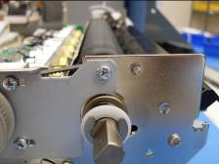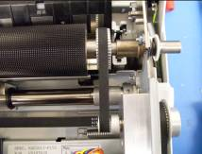
M3X8 Screw w/ nut

- Remove one M3X8 screw without lockwasher from the arm of the assembly

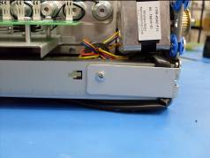
M3X8 Screw

- Remove one M3X8 screw without lockwasher from the front bar lever clamp (003-0301-001).

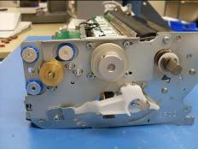

- Move the adjustment arm off of the assembly

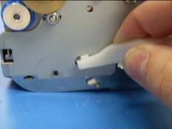

- Unplug the motor cable from the platen motor

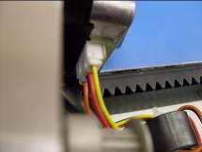
Small gear box gear

Platen Motor Cable

- Slide platen motor assembly away from the platen to remove it from the unit.

11.2 Replacing the Platen Motor Assembly
- Take the new platen motor assembly and slide it into the mechanical assembly toward the platen. Lift up the adjustment arm and set it in the hole cut for it.

- Plug in motor cable to the motor.

Small gear box gear

Platen Motor Cable

- Replace the M3X8 screw with no lockwasher through the front bar lever clamp and into the screw hole, making sure that the clamp goes over the adjustment arm.

- Replace the M3X8 screw with no lockwasher into the arm of the assembly. Make sure that the motor cable is as far to the right as it can be, otherwise you could damage the wires.

Platen Motor Cable

M3X8
Screw

- Replace the M3X8 screw with no lockwasher and M3 nut into the top part of the assembly.

M3X8 Screw W/ Nut

- Hook the inside platen belt around the large gear on the platen and the small gear on the gear box.

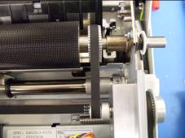

- Pull the gear box away from the platen and tighten the four M3X8 screws on the gear box.

M3X8 Screws

- Place the outside belt around the large gear on the gear box and the gold gear on the platen motor.
- Pull the motor away from the gearbox and tighten the three M3 nuts that hold the motor in place.

M3 Nuts

- Both belts should be tight, but still have a little give when you push on them.
- Replace mechanical assembly. See Section 16.2.
- Replace case. See Section 5.2.

12. Replacing a Solenoid
You may need to replace a solenoid if one burns out, is damaged or is tearing paper. See Section 6 to find out if a blank column is caused by the solenoid or is caused by a failed motor driver on the mainboard. If a solenoid does need to be replaced, it can be done without taking the main part of the case off.

12.1 Removing the solenoid
- Lift both pieces of the lid and pull upwards, you may need to swivel the lid back and forth a bit to find the right spot.

- Remove one case screw from the white paper bail.

- Flip white paper bail up.

- Remove the paper bail by pulling upwards, you may need to rock it a little to find the right spot.
- Grip the largest part of the solenoid with a pair of pliers. If you grab the smaller part, the larger part can spin and it can damage the wires.

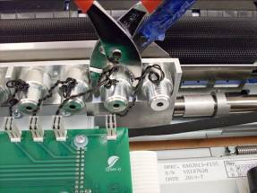

- On the other side of the carriage, use a ½” open ended flat wrench to loosen the brass nut on the solenoid.
- Remove the brass nut from the solenoid and pull the solenoid out of the carriage block.
- Unplug the connector of the solenoid from the interconnect board.

12.2 Replacing a Solenoid

- Place new solenoid in the vacant hole, placing the brass nut over the end of the solenoid after it starts to pass through the hole.
- Start the nut onto the threads and tighten it about half way. Make sure the solenoid is seated all the way into the hole before tightening the rest of the way.
- Hold the solenoid still using the pliers in the same way as before. If you grab the smaller part of the solenoid the larger part can turn and damage the solenoid wires. Get the nut as tight as you can.
- Plug the connector into the interconnect board.
- Replace white paper bail.

- Push the paper bail flat and replace the case screw.

- Replace lid.

- You will need to adjust the punch force of the new solenoid in the toolbox under the solenoid calibration button.

13. Replacing the Carriage
The carriage may need to be replaced if there has been damage due to shipping or being dropped. It is not normally something that needs to be replaced. However, have recently changed to a new sensor type, which requires a different style of carriage block. So if you have a printer that is giving you problems with the alignment sensor and you want to switch to the new style, the carriage block will have to be replaced as well.

13.1 Removing the Carriage
- Remove case. See Section 5.1.
- Remove mechanical assembly. See Section 16.1.

M3X8 Screws

- Remove platen motor assembly. See Section 11.1.
- Remove the two M3X8 Screws holding the white bearing block to the carriage.

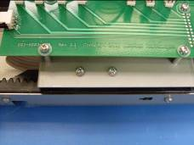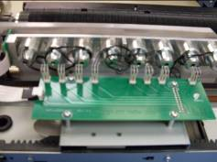
M3X8 Screws

- Detach the carriage belt spring from the metal supports using either a pair of pliers or a positioning hook.

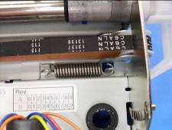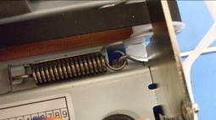
Carriage Belt Spring

- Loosen the set screws holding the metal collars on the shaft in place.

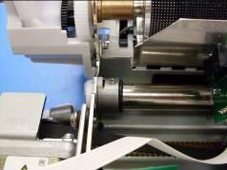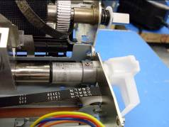
Collar Set Screws

- Remove the front lever bar clamp from the large arm of the shaft.
Clamp
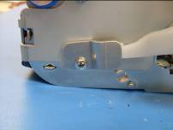
- Spin the small arm on the end of the shaft so that the plastic tab on the inside of the mechanical assembly lines up with the hole in the metal.

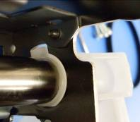

- Start pulling shaft out of mechanical assembly, after the end of the shaft comes out of the left side of the mechanical assembly, slide the collar and O-ring off the left end of the shaft. Then continue sliding the shaft out while keeping the carriage in the same place. Remove the shaft completely. This will also remove the O-ring, spacer and collar from the right side of the shaft.
- Unplug all the solenoid connectors from the Interconnect board as well as the alignment sensor.

- Remove the 4 M3X8? Screws with lockwashers and plastic washers from the Interconnect board.

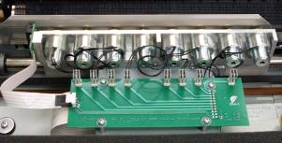
M3X8 Screws

- Unplug ribbon cables from the bottom of the interconnect board.
Ribbon Cables
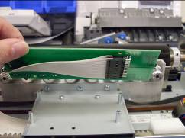

- Remove two M3X8 screws with lockwasher from the carriage plate that go into the belt clamp.

M3X8 Screws

- Lift carriage out of mechanical assembly.

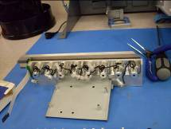

- Depending on what is wrong with the carriage you may need to transfer the solenoids, cable mounting plate, paper guide and alignment sensor over to a new carriage block.

13.2 Replacing the Carriage
- Place the new carriage into the mechanical assembly.
- Pull the carriage belt around the small section of belt teeth line up with the grooves of the belt clamp

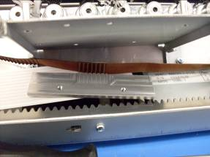

- Replace the two M3X8 screws with lockwasher through the holes in the cable plate and into the belt clamp
- Make sure that the teeth on the rest of the belt are on the side with the motor.

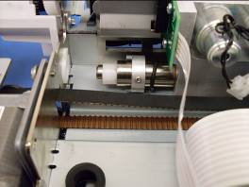

- Take the interconnect board and plug the ribbon cables into them. Make sure that the connectors to the solenoids are next to the solenoids.

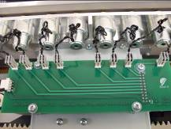

- Replace the four M3X8 screws with lockwashers and plastic washers into the interconnect board.

M3X8 Screws

- Plug in the solenoids, they plug into the board in the same order they are on the carriage
- Plug in the alignment sensor.
- Take the shaft and then slide the shaft through the hole in the right side of the mechanical assembly.
- Add the collar on the end making sure that the cut out in the collar is toward the arms of the shaft. Then add the spacer and O-ring so that the O-ring is closest to the carriage.
- Then slide the shaft through the carriage. Before you slide the shaft into the left side of the mechanical assembly replace the O-ring and collar onto the shaft.

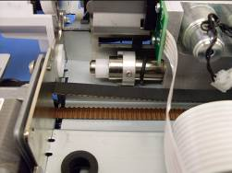

- Line up the tab on the small arm of the shaft with the notch in the hole on the right side of the mechanical assembly. Slide the end of the shaft into the left side of the mechanical assembly.

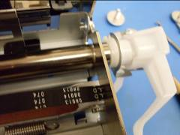

- Position the small arm on the 6th groove from the top of the marks on the right side of the mechanical assembly. Position the large arm so that its end sits in the hole.

- Replace the front bar lever clamp over the large arm of the shaft.
Clamp

- Tighten the set screws on the collars.

Collar Set Screws

- Reattach the spring that tensions the carriage belt. You will need to use either pliers or a positioner hook to do this.

Carriage Belt Tensioning Spring

- Replace white bearing block so that the edge of the mechanical assembly that is scalloped fits into the slot in the block.

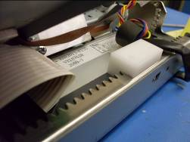

- Replace the two M3X8 screws without lockwasher through the carriage plate and into the white block. Be careful not to tighten the screws too much or you will strip the threads out of the plastic.

- Replace Platen. See Section 10.2.
- Replace Mechanical Assembly. See Section 16.2.
- Replace Case. See Section 5.2.
- The alignment will have to be redone after changing the carriage.

14. Replacing the Carriage Paper Guide
This will need to be done when changing over from the old plastic strip to the new metal hardware as well as when it might be damaged in shipping or if it is very loose and the printer is tearing paper.

14.1 Removing the Paper Guide

- Remove case. See Section 5.1.
- Remove Mechanical Assembly. See Section 16.1.
- Remove Carriage. See Section 13.1.

- Once the carriage is removed from the mechanical assembly, turn it around so that the curve of the paper guide is toward you.

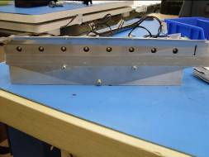
Paper Guide Screws

- Remove the two or three screws from the paper guide.

14.2 Replacing the Paper Guide
- Place new paper guide (if you are upgrading to new hardware the new paper guide will be different from the old one) in the same direction as the one you took off.
- Replace the three screws you took out (which may have lockwashers) with two M3X6 screws with no lockwasher and add a little loctite to the threads of the screws into the top two holes only.
- Replace Carriage. See Section 13.2.
- Replace Mechanical Assembly. See Section 16.2.
- Replace Case. See Section 5.2.
- You will need to run the alignment sensor threshold calibration, but you should not need to realign the printer.

15. Replacing the Interconnect Board
You may need to replace the interconnect board if it is damaged or if you cannot get the alignment sensor to read, but have already tried replacing the sensor with no success. You do not need to remove the case for this replacement.

15.1 Removing the Interconnect Board

- Remove the top lid. Lift both pieces of the lid and pull upwards, you may need to swivel the lid back and forth a bit to find the right spot.

- Unplug all the solenoids and the alignment sensor from the interconnect board.
Solenoid connectors
Alignment Sensor Connector

- Remove the four M3X8 screws with lockwashers and plastic washers.
- Lift the interconnect board up partway and unplug the ribbon cables on the underside of the interconnect board.

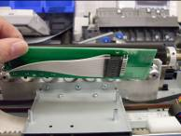

- Remove interconnect board.

15.2 Replacing the Interconnect Board
- Plug the ribbon cables into the underside of the new interconnect board. Make sure that the board has the alignment sensor and solenoid connectors are in the proper direction.
M3X8 screws

- Replace the four M3X8 screws with lockwashers and plastic washers into the interconnect board.
- Replug in all of the connectors. The solenoids plug into the board in the same order as they are in the carriage.
- Replace the lid.
- You will need to double check that the alignment has not altered.

16. Replacing the Mechanical Assembly
The only reason you should need to replace the mechanical assembly is if it is damaged.

16.1 Removing the Mechanical Assembly
- Remove Case. See Section 5.1.
- Remove the three M3X12 screws with lockwashers going into the platen motor.

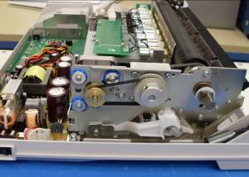
M3X12 Screws

- Remove the outside platen belt.

- Push the motor as far away from the platen as it will go and rotate it slightly so that the large mechanical assembly screw is accessible.

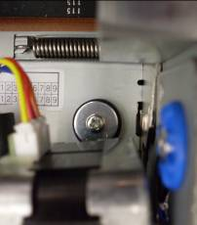

- Cut the zip tie that is holding the ferrite bead away from the carriage motor gear.

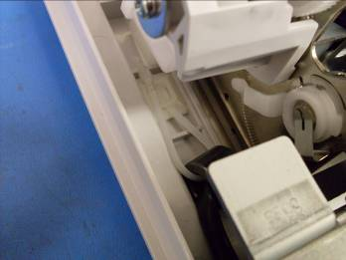

- Remove mechanical assembly screws.

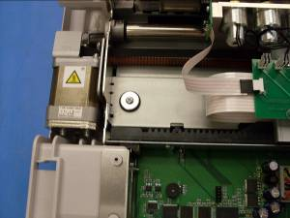
Mechanical Assembly Screws

- Lift up the front end of the mechanical assembly part way so you can see under it.

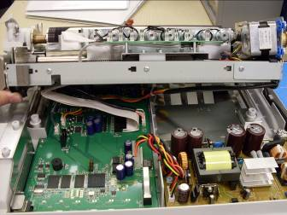
Cables to unplug

- Reach underneath it and unplug the ribbon cables, platen motor cable, carriage motor cable and the single sheet feed sensor cable.

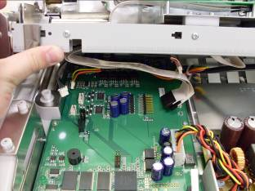

- Lift the mechanical assembly out of the unit. There are metal feet in the back covered with a rubber piece that may cause you to have to pull forward a little while lifting it out.

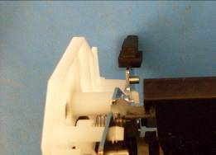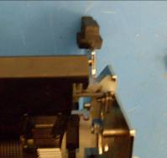

- If you are replacing only the mechanical assembly part of it you will need to remove all the other components. Including the black cable holder that keeps the ribbon cables in place. You can leave the ribbon cables attached to the carriage and just take the black holder out.
- Remove Carriage. See Section 13.1.
- Remove the Platen. See Section 10.1.
- Remove Platen Motor Assembly. See Section 11.1.

16.2 Replacing the Mechanical Assembly
- Replace Platen. See Section 10.2.
- Replace the black ribbon cable holder with the ribbon cables attached if you detached it from the carriage.
- Replace Carriage. See Section 13.2.
- Replace the Platen Motor Assembly. See Section 11.2.
- Sit the mechanical assembly down into the base of the unit making sure that the feet at the back of the unit have the rubber covers on them and are sat down and back into their holes.

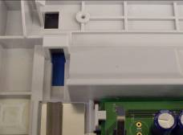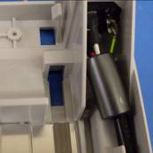

- Lift the front of the mechanical assembly up and plug in all the cables.

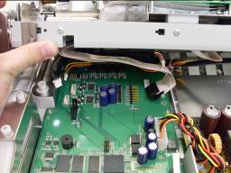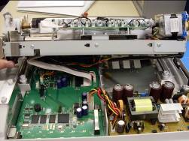
Cables to plug in

- Seat the mechanical assembly down over the boards so that the holes for the mechanical assembly screws line up with the plastic columns that the screws go into.

Mechanical Assembly Screws

- Replace mechanical assembly screws. In some of the models the rubber washers that sit around the holes come off. Make sure they are around the holes before you tighten down the screws.

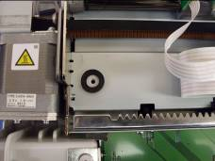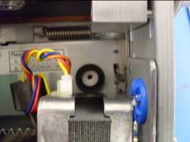

- Replace the zip tie that holds the ferrite bead away from the carriage motor gear.

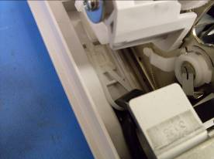

- Replace case. See Section 5.2.
- You will need to redo the alignment after replacing the mechanical assembly.

17. Replacing the Ribbon Cables
The only real reason you should need to replace the ribbon cables is if they have been damaged.

17.1 Removing the Ribbon Cables
- Remove case. See Section 5.1.
- Remove mechanical assembly. See Section 16.1.
- Remove the carriage. See Section 13.1.
- Remove the black plastic ribbon cable holder from the mechanical assembly by pressing in the tab on the holder.

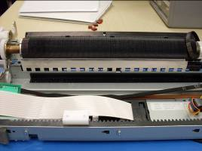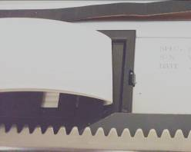
Holder Tab
Ribbon Cable Holder

- Slide the ribbon cables out of the black holder.

17.2 Replacing the Ribbon Cables
- Slide new ribbon cables into the black holder. Make sure that the grey stripe of the ribbon cable is toward the platen.

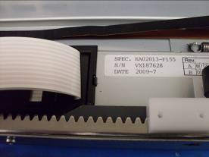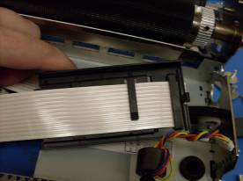

- Replace the ribbon cable holder into the mechanical assembly.
- Replace carriage. See Section 13.2.
- Replace mechanical assembly. See Section 16.2.
- Replace case. See Section 5.2.

18. Replacing the Plastic Strip with the Paper Deflector
Any of the units that come in with a plastic strip will need the plastic strip replaced with new hardware. This will fix skew and other printing problems. This upgrade is considered to be under warranty and we do not charge for it.

18.1 Removing the Plastic Strip

- Remove case. See Section 5.1.
- Remove mechanical assembly. See Section 16.1.
- Remove platen. See Section 10.1.
- Remove carriage. See Section 13.1.
- Pull paper pan up by lifting the inside corners of the paper pan from the back. Once you have it lifted the inside edge pull the paper pan away from the mechanical assembly to remove its tabs from the notches.

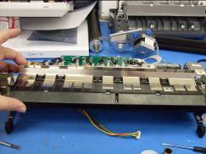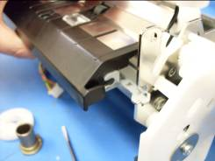
Paper Pan

- Remove the tape that is holding the single sheet feed wire in place. Set the paper pan aside. Do not take the wire all the way out of the machine. Removing the tape is only intended to give you some slack on the wire.

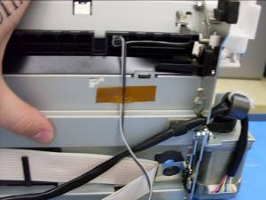
Single Sheet Feed Sensor Tape

- Push the tabs of the black paper guide in and remove it from the mechanical assembly.

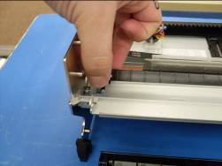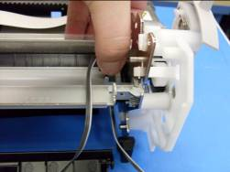
Tabs of the Black Paper Guide

- Set the black paper guide aside.

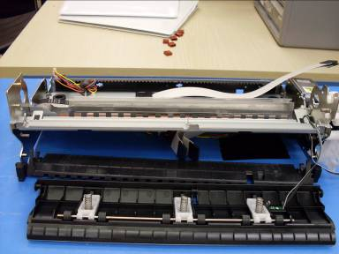

- Remove the metal strip that the plastic strip is attached to. Many find it easier to remove it from the bottom of the unit. Some people prefer to grab it with pliers and rip it out quickly, others prefer to use a flathead screw driver to dislodge the piece from the mechanical assembly.

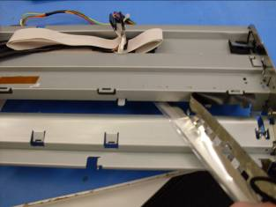
Discard after removal

- After removal, toss it in the trash.

18.2 Installing the Paper Deflector

- Flip the mechanical assembly back over so that it is right side up.
Paper Deflector

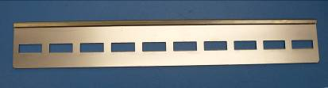

- Remove the protective cover from the adhesive strip on the paper deflector.

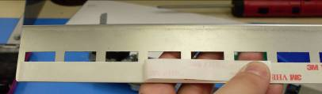

- Place the new paper deflector onto the mechanical assembly on the outside of where the other piece used to be. Make sure to line up the left edge of the paper deflector with the left edge of the cut out and the bottom of the deflector is against the bottom of the mechanical assembly.

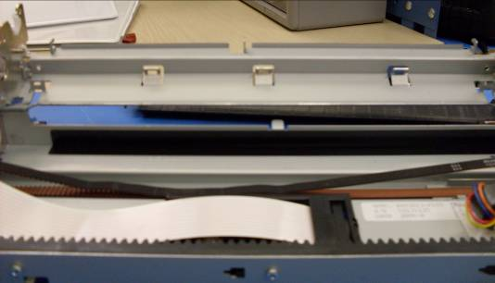
Cut out: line the left edge of the paper deflector up here

Paper Deflector goes over the black support. This is a reflection

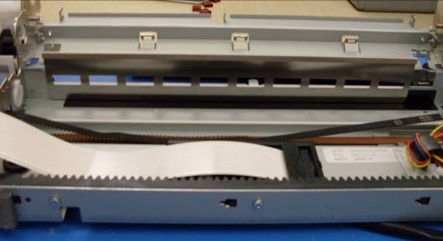

- Replace black paper guide by placing it in the mechanical assembly and pushing down gently until the tabs click back into place

- Replace paper pan by inserting the tabs into the notches on the mechanical assembly and pressing down gently.

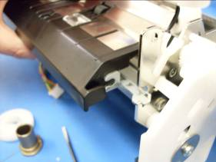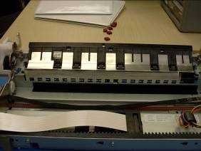

- Retape the single sheet feed wire in place on the underside of the mechanical assembly. Make sure that the wire is run properly as shown in the picture, if it is not it can interfere with the paper path switch on the mainboard and also the home flag sensor on the mainboard.

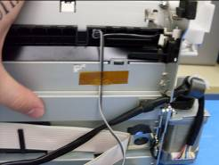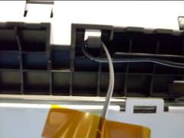

- Replace Carriage. See Section 13.2.
- Replace Platen. See Section 10.2.
- Replace mechanical assembly. See Section 16.2.
- Replace case. See Section 5.2.
- The alignment will need to be redone. Before you start realigning the printer, update the firmware to the newest version and add an ‘A’ to the end of the serial number through the toolbox. An example would be CMX2999A for a max. Double check that the serial number change worked by closing the toolbox and then opening it back up again.

19. Replacing the Mainboard
The mainboard may need to be replaced for a number of different reasons. If the printer is not turning on, but you can hear the power supply power up, then the mainboard is most likely the problem. Also if you have solenoid that is not firing and you used Section 6 to determine that the problem was with the board and not the solenoid. NOTE: There is a small switch toward the back of the board (the paper path switch) that has a small metal tab. This will NOT come with a new mainboard so you need to make sure and take it off of the bad board and place it onto the new one.

19.1 Removing the Mainboard
- Remove case. See Section 5.1.
- Remove the mechanical assembly. See Section 16.1.
- Unplug the power supply cable.
- Remove the two M3X8 screws holding the USB grounding plate in place from the outside of the printer.

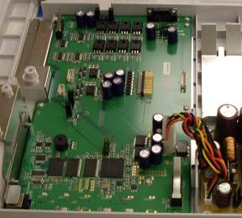
USB Grounding Plate Screws
Power Supply Cable

- Remove the 5 M3 plastite screws from the mainboard.

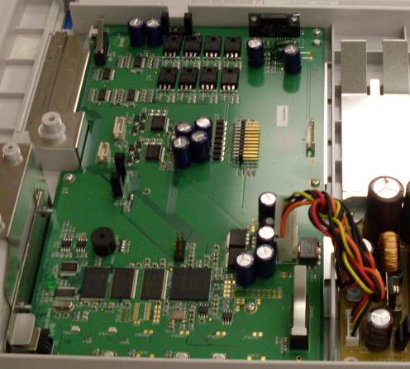
Paper Path Switch
Mainboard Screws

- Remove the Mainboard. Make sure to also remove the metal part of the paper path switch using a pick, to use on the new mainboard.

19.2 Replacing the Mainboard
- Attach the metal part of the paper path switch onto the switch on the new mainboard.
- Place new mainboard into the base and replace the 5 M3 plastite screws.
- Replace the USB grounding plate using two M3X8 screws from the outside of the printer.

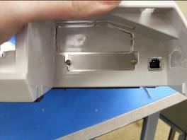

- Plug the power supply cable back into the mainboard.

Power Supply Cable

- Replace mechanical assembly. See Section 16.2.
- Replace case. See Section 5.2. If you choose to align the printer with the case off DO NOT FORGET TO REMOVE THE TAPE BEFORE REPLACING THE CASE!
- When you turn the printer on for the first time after replacing the mainboard, it may beep three slow beeps with the green light flashing, pause then beep a fourth time with the amber light coming on and staying on. To reset the mainboard turn the printer off, then hold down the two outside buttons (the ‘Cancel’ and ‘Paper down’ buttons) and turn the printer on. Continue to hold the buttons down while it beeps three slow beeps with the green light flashing, pauses beeps again with the amber light on and then it will beep an additional time and the light will go back to green. Let go of the buttons and turn the printer back off. When you turn the printer on again it should give you three fast beeps with the green light on.

- When you open the toolbox for the first time after changing the mainboard, click on the service tab and okay on the warning pop-up window that comes up.

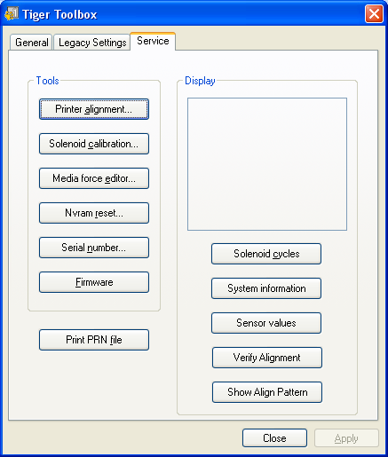

- Then click on the ‘Nvram reset’ button on the left hand side of the toolbox. In the pop-up window click on the ‘level three’ button and wait for the printer to beep three times.

- After it beeps three times click on the cancel button.

- Now click on the ‘Serial number’ button and enter the serial number into the pop-up window, if your printer has the newest firmware and/or you just upgraded from a plastic strip to a metal paper deflector you will need to add an A after the serial number (Ex. CMX2999A). Click okay.

- Click on the ‘Printer alignment’ button on the top left of the toolbox.

- Have a blank piece of Braille paper ready.
- Click on the ‘Cal. Paper Sensor Thresholds’ button.

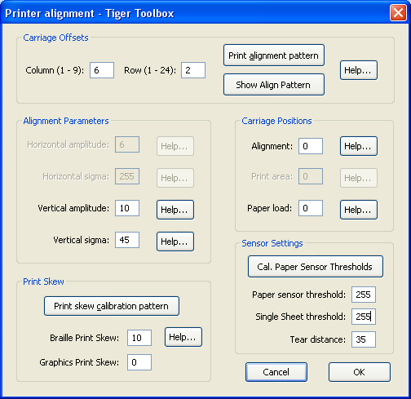

- The platen will begin to spin slowly. Insert the paper into the upper paper path, putting the paper as far to the right as it will go and let the printer pull the paper through.

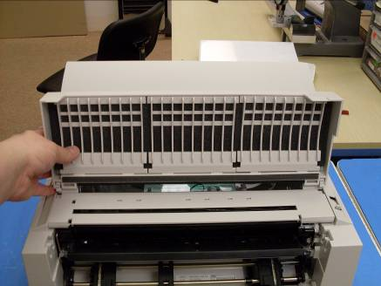
Upper Paper Path

- Once the printer has pulled the paper all the way through the printer and the platen has stopped moving, close the window by clicking on the cancel button. The paper sensor thresholds and the single sheet thresholds are now set.

- Reopen the ‘Printer alignment’ widow and check to see that the threshold values have changed. The ‘Paper sensor threshold’ box should contain a value between 90 and 190 if the value is outside this range then try the calibration again, if it is still outside the range then you may need a different alignment sensor. The ‘Single Sheet threshold’ should be between 90 to 190.

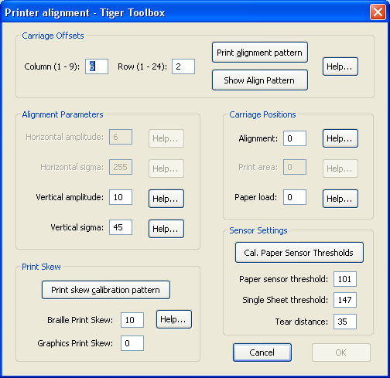

- The alignment will need to be done.

20. Replacing the Single Sheet Feed Sensor
The single sheet feed sensor may need to be replaced if the printer can no longer tell if there is a piece of paper covering the sensor. When you place the paper path switch into single sheet feed mode you should be able to place a piece of paper over the sensor have the machine should advance the paper into the platen. You can check to see if the sensor is reading my going into the service tab of the toolbox and clicking on the ‘sensor values’ button.

20.1 Removing the Single Sheet Feed Sensor

- Remove Case. See Section 5.1.
- Remove mechanical assembly. See Section 16.1.
- Remove Platen. See Section 10.1.

- Remove the paper pan by pulling upward gently on the inside edge of the paper pan.

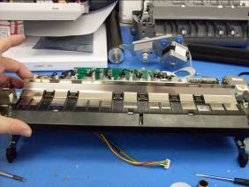
Single Sheet Feed Sensor

- Remove the single sheet feed sensor from the back of the paper pan by pushing the tabs inwards and pushing the sensor and cover through the paper pan.

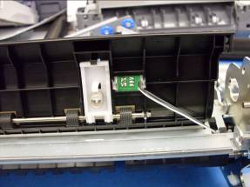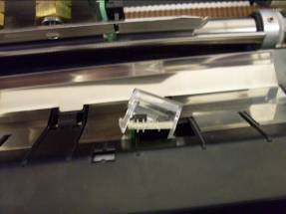

- Flip the mechanical assembly over and take the tape off of the single sheet feed sensor wire.

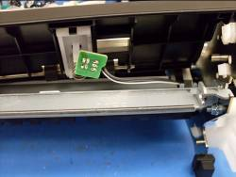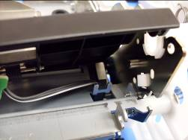

- Pull the sensor wire out of the mechanical assembly

20.2 Replacing the Single Sheet Feed Sensor
- Place the new single sheet feed sensor into the paper pan. The sensor does not sit down into the plastic cover only between the tabs, the cover rests on the sensor.

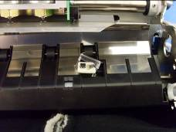

- Run the wire down through the hole the tabs of the black paper guide sit in, through the hook on the underside and tape the wire back in place

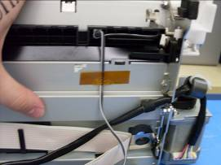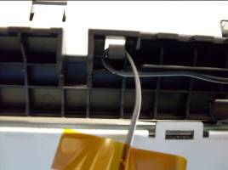

- Replace platen. See Section 10.2.
- Replace mechanical assembly. See Section 16.2.
- Replace case. See Section 5.2.

21. Replacing the Power Supply
The power supply may need to be replaced if the unit is not turning on and you can already ascertained that it is not the mainboard.

21.1 Removing the Power Supply
- Remove case. See Section 5.1.
- Unplug the power supply cable that plugs into the mainboard and the cable coming from the power plug in assembly.

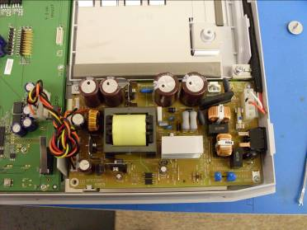
Screws
Unplug

- Remove 3 M2 plastite screws from the corners of the power supply and remove it from the base.

21.2 Replacing the Power Supply
- Place new power supply into the base. Make sure that the on/off switch lines up to the hole in the side of the base.

Screws
Plug In

- Plug in the power supply cable to the mainboard and the power plug in cable to the power supply
- Replace the 3 M3 plastite screws.
- Replace Case. See Section 5.2.

